**Ecommerce Web Application**

**MAJOR PROJECT REPORT**

SUBMITTED IN PARTIAL FULFILMENT OF THE REQUIREMENT FOR THE

AWARD OF THE DEGREE OF

**BACHELOR OF TECHNOLOGY**

(Computer Science & Engineering)



Submitted By: Submitted To:

Piyush Goyal (2104153) Mr.Kapil Sharma

Mrs.Priyanka arora

**DEPARTMENT OF COMPUTER SCIENCE AND ENGINEERING**

**GURU NANAK DEV ENGINEERING COLLEGE**

**LUDHIANA , 141006**

JANUARY 2025



**Abstract**

E-commerce has transformed the way businesses and consumers interact, offering a convenient, scalable platform for online transactions. This project aims to design and develop a web application using Python and the Django framework to provide a seamless and secure online shopping experience. The platform will include essential modules such as user registration, product management, order placement, and payment processing. The user registration module will allow customers to create and manage their accounts, track order history, and personalize their shopping experience. Product management will enable administrators to easily add, update, and categorize products, while the order placement feature will facilitate adding items to the shopping cart and completing purchases. A secure payment processing system will be integrated to ensure safe and encrypted transactions for users. Scalability is a primary objective of the project. The system will be designed to accommodate growing user demands and transaction volumes, ensuring that the platform can expand and adapt to evolving business needs. The architecture will support future enhancements, such as the integration of AI-based product recommendations and advanced data analytics. Security is a key consideration, and the application will follow best practices to protect sensitive customer data. This includes using secure communication protocols, encrypted data storage, and adhering to industry standards like PCI DSS for payment transactions. User authentication will be implemented with features like password hashing and multi-factor authentication to ensure secure access to the platform. In conclusion, this e-commerce web application aims to provide businesses with a reliable, scalable, and secure platform while offering customers a seamless and user-friendly online shopping experience. The project will lay the groundwork for future integrations and continued growth, ensuring long-term success in a competitive digital market.

**ACKNOWLEDGEMENT**

We are highly grateful to the Dr.Sehijpal Singh, Principal, Guru Nanak Dev Engineering College (GNDEC), Ludhiana, for providing this opportunity to carry out the major project work at Council of Cyber Vigilance & Security Enforcement.

The constant guidance and encouragement received from Dr.Kiran Jyoti H.O.D. CSE Department, GNDEC Ludhiana has been of great help in carrying out the project work and is acknowledged with reverential thanks.

We would like to express a deep sense of gratitude and thanks profusely to *Project Guide Name*, without his/her wise counsel and able guidance, it would have been impossible to complete the project in this manner.

We express gratitude to other faculty members of computer science and engineering department of GNDEC for their intellectual support throughout the course of this work.

Finally, we are indebted to all whosoever have contributed in this report work.

**Piyush Goyal**

**LIST OF FIGURES**

|  |  |  |
| --- | --- | --- |
| Fig. No. | Figure Description | Page No. |
| 1 | ER-Diagram | 5 |
| 2 | Data Flow Diagram (DFD) | 6 |
| 3 | User Interface Design Screenshots | 7 |
| 4 | Database Design | 8 |
| 5 | Backend Interface Screenshots | 9 |

**LIST OF TABLES**

|  |  |  |
| --- | --- | --- |
| Table No. | Table Description | Page No. |
| 1 | Category Table | 10 |
| 2 | Products Table | 11 |
| 3 | Orders Table | 12 |
| 4 | User Registration Table | 13 |
| 5 | Cart Table | 14 |
| 6 | Cart Item Table | 15 |

**TABLE OF CONTENTS**

|  |  |
| --- | --- |
| Contents | Page No. |
| *Abstract* | **i** |
| *Acknowledgement* | **ii** |
| *List of Figures* | **iii** |
| *List of Tables* | **iv** |
| *Table of Contents* | **v** |
| Chapter 1: Introduction  ………….. | 1 |
| Chapter 2: Requirement Analysis and System Specification  ………….. | ... |
| Chapter 3: System Design  ………….. | ... |
| Chapter 4: Implementation and Testing  ………….. | ... |
| Chapter 5: Results and Discussions  ………….. | ... |
| Chapter 6: Conclusion and Future Scope  ………….. | ... |
| References | ... |
| Appendix A: Development Environment | ... |

**Chapter 1: Introduction**

1.1 Introduction to Project

In the modern business environment, achieving growth requires more than just traditional methods. As the world rapidly shifts towards digital platforms, businesses must adapt to stay competitive. The introduction of e-commerce has revolutionized how businesses interact with customers, enabling them to reach a global audience while improving user experience, increasing sales, and reducing operational costs. This project focuses on creating an e-commerce platform for an offline business, providing a seamless online experience that extends the business's reach, enhances customer interaction, and boosts profitability. By leveraging the power of the internet, businesses can offer 24/7 availability, a wide range of products, and personalized recommendations, all while simplifying payment and order processes.

1.2 Project Category

The project falls under the category of Application Development in the domain of E-commerce. It involves the design and development of a web-based application that facilitates online transactions between businesses and customers. The system will enable businesses to showcase products, handle customer interactions, and manage transactions in a digital environment, providing convenience to both the business owners and their customers

1.3 Problem Formulation

Businesses, particularly small-scale offline businesses, face numerous challenges in expanding their reach and increasing sales. Limited physical store presence, time constraints of customers, and the inability to serve a larger customer base can restrict business growth. The problem lies in the lack of an effective and accessible platform for businesses to cater to the modern consumer’s preferences—convenience, 24/7 availability, and seamless online transactions. There is a need for an e-commerce solution that can help businesses bridge this gap and cater to the growing demand for online shopping.

1.4 Identification/Recognition of Need

With increasing customer reliance on the internet for shopping, businesses must acknowledge the need for an online platform to remain competitive. The recognition of this need arises from the following challenges:

* Limited operational hours for offline businesses.
* Difficulty in reaching a broader customer base.
* The inconvenience of traditional shopping for time-pressed consumers.
* Increasing demand for convenience, variety, and competitive pricing. To address these challenges, businesses must transition to an e-commerce model that offers easy access, flexible shopping options, and real-time customer interaction.

1.5 Existing System

Currently, many offline businesses operate within traditional brick-and-mortar settings, lacking an online presence. Customers must visit physical locations to purchase products, resulting in limited accessibility. Additionally, the customer experience is limited to in-store interactions, with no option for browsing products online or making purchases after business hours. The existing systems are often inefficient, requiring manual tracking of sales and inventory, and they do not offer the seamless integration of payment, product recommendations, or order tracking that modern consumers expect.

1.6 Objective

The primary objective of this project is to design and develop an e-commerce website that allows businesses to:

* Reach a broader audience by operating 24/7.
* Offer an improved user experience that encourages customers to make purchases.
* Increase customer satisfaction through easy access to products and services.
* Streamline business operations by automating processes such as inventory management, order tracking, and payment processing.
* Generate higher sales and profits by leveraging digital marketing techniques and offering a global reach.
* Reduce operational costs by minimizing the need for physical store maintenance and increasing business efficiency.

Other key objectives include:

1. Ensuring continuous availability of products/services (24\*7).
2. Expanding the business's reach to a global market.
3. Improving customer engagement through personalized experiences.
4. Enhancing brand visibility and awareness.
5. Utilizing better marketing strategies to attract and retain customers.

1.7 Proposed Syste

The proposed system is an e-commerce platform that will serve as the digital storefront for an offline business. This platform will allow customers to browse and purchase products online, from the comfort of their homes, at any time. The system will include features such as:

* User-friendly navigation to enhance customer experience.
* A secure payment gateway for smooth transactions.
* Inventory management tools to keep track of stock.
* Product recommendation engine based on customer browsing history.
* Order tracking functionality to keep customers informed.
* Integration with shipping services for faster delivery.

The platform will be designed to support mobile and desktop users, ensuring that it is accessible across all devices.

1.8 Unique Features of the Proposed System

The proposed e-commerce platform will have several unique features designed to improve user experience and business efficiency:

* **24/7 Availability:** Customers can shop at any time, breaking the constraints of physical store hours.
* **Product Recommendations:** The system will suggest related products based on customer browsing behavior, increasing the likelihood of additional sales.
* **Global Reach:** The online platform allows the business to cater to customers worldwide, opening new markets.
* **Seamless User Interface:** The website will be designed with an intuitive UI, making it easy for customers to find and purchase products.
* **Automated Operations:** From inventory tracking to order fulfillment, the system will automate many business processes, saving time and reducing errors.
* **Mobile Responsiveness:** The platform will be optimized for mobile devices, ensuring a smooth shopping experience across various devices.
* **Integrated Marketing Tools:** The system will support digital marketing features such as email campaigns and promotional discounts to attract and retain customers.

This combination of features will set the proposed system apart, ensuring the business can scale, increase customer satisfaction, and generate higher profits.

**Chapter 2: Requirement Analysis and System Specification**

2.1 Feasibility Study (Technical, Economical, Operational)

The feasibility study for the proposed e-commerce platform is an essential step to assess the viability and practicality of the system from three perspectives: technical, economical, and operational. It aims to determine if the project is achievable, sustainable, and aligned with the goals of the business.

1. Technical Feasibility

Technical feasibility focuses on the capability of the technology, hardware, and software to support the proposed system and meet the business requirements.

**Platform and Technology Stack:** The e-commerce website will rely on modern web technologies such as

* Frontend: HTML5, CSS3, JavaScript (with frameworks like React, Vue.js, or Angular) for a responsive and dynamic user interface.
* Backend: A reliable server-side framework such as Node.js, Django (Python), or Laravel (PHP) will handle business logic, user management, and payment transactions.
* Database: SQL-based databases like MySQL or PostgreSQL will store customer, product, and order data, while NoSQL options (like MongoDB) may be used for more scalable data models.
* Payment Gateway Integration: The platform will integrate third-party payment systems such as PayPal, Stripe, or Razorpay to securely process transactions.
* Security: The system will use SSL encryption, two-factor authentication, and regular security audits to ensure the protection of sensitive customer data, such as payment details and personal information.

Infrastructure and Hosting:

* The platform will be hosted on a cloud service provider (AWS, Google Cloud, or Microsoft Azure) to ensure high availability, reliability, and scalability.
* Content Delivery Network (CDN) will be used for faster content delivery to global customers.
* Server Load Balancing and Auto-Scaling will be implemented to handle high traffic volumes, particularly during peak sales periods.

Scalability and Maintenance:

* The system will be designed with scalability in mind to accommodate future growth, whether through additional product listings, user accounts, or higher transaction volumes.
* The architecture will support modular updates and maintenance to ensure continuous improvement without disruption to the user experience.

Technical Constraints:

* Efficient coding practices will be followed to ensure that the platform performs well even on lower-end devices.
* The website's database size will be managed carefully to optimize performance and minimize latency.

2. Economical Feasibility

Economic feasibility examines whether the project is financially viable and if the costs involved can be justified by the expected returns.

Development Costs:

* The initial development will require costs for hiring skilled developers, designers, and other professionals, as well as purchasing any third-party tools or software required.
* Cloud Hosting and Infrastructure: There will be recurring costs for cloud hosting, databases, and other services (e.g., email marketing tools, analytics platforms).
* Payment Gateway Fees: Payment gateways charge a transaction fee for each sale, which will affect profit margins.

Operational Costs:

* Ongoing expenses will include server maintenance, updates, security patches, customer support, and marketing efforts (advertising, promotions, and SEO).
* Marketing and Customer Acquisition Costs: Strategies like online ads, social media campaigns, and email marketing will incur additional costs. However, these efforts are expected to bring in consistent traffic and sales.

Revenue Generation:

* The platform’s primary source of revenue will come from product sales, including both direct sales and commissions for third-party sellers.
* Additional revenue streams can be generated through advertising, affiliate marketing, and premium services (e.g., subscriptions for premium memberships or exclusive products).
* Transactional Fees: The platform may also charge sellers a commission on each sale made through the site.

Return on Investment (ROI):

* The expected ROI is promising, given the growing e-commerce market and the business's ability to scale. By providing a seamless, user-friendly shopping experience and utilizing targeted marketing efforts, the platform can attract a large number of customers, increasing both revenue and brand visibility.

Profitability:

* With efficient operations, reduced overhead costs compared to physical stores, and an expanding customer base, the platform has the potential to reach profitability within the first year of operations. The business model is based on recurring revenue, making it sustainable in the long term.

3. Operational Feasibility

Operational feasibility assesses the ability of the organization to manage and run the proposed system, focusing on day-to-day operations, customer service, and vendor management.

User Acceptance:

* The system will be easy to use, and the general public is already accustomed to shopping online. This makes user adoption highly feasible.
* With a well-designed user interface (UI) and user experience (UX), the platform will cater to both novice and experienced online shoppers. A smooth, intuitive experience is essential to attracting and retaining customers.

Vendor and Product Management:

* The platform will allow vendors to list products, manage inventory, and fulfill orders. Integration of vendor-specific dashboards and real-time inventory tracking will ensure smooth operation for both customers and vendors.
* Customer Interaction: Customers will be able to interact with vendors via the chat system, ask questions, and clarify details before making a purchase.

Customer Support:

* The platform will integrate a robust customer support system, including live chat, email support, and frequently asked questions (FAQ) sections.
* Automated systems such as chatbots can help address basic customer queries, while dedicated customer support agents will handle more complex issues.

Order Fulfillment:

* The platform will support multi-vendor sales, so it must integrate with third-party logistics (3PL) providers for shipping and tracking.
* Clear communication regarding order status, tracking numbers, and estimated delivery times will be provided to customers.

Compliance and Legal Considerations:

* The platform will comply with data protection laws such as GDPR (for European users) or CCPA (for California residents), ensuring customers' data privacy and rights.
* Terms and Conditions will be clearly outlined on the website, along with return/refund policies and shipping details.

Training and Support for Employees:

* Employees will need training in managing product listings, processing orders, handling customer complaints, and maintaining security standards.
* Ongoing technical and customer support training will ensure the team is equipped to handle any operational issues effectively.

Maintenance and Upkeep:

* Routine maintenance will ensure that the platform remains up to date with new technologies and security protocols.
* Updates to the product catalog, customer data, and system security will be performed regularly to ensure the platform runs smoothly and securely.

Summary of Feasibility Study

Technical Feasibility: The project is technically viable with modern technologies, secure systems, and a scalable infrastructure. The platform will be responsive, reliable, and easy to maintain.

Economic Feasibility: The platform’s potential for generating revenue through product sales, commissions, and additional services ensures its economic viability. Initial and operational costs are manageable and can be offset by long-term profits.

Operational Feasibility: The system is operationally feasible, with user-friendly features, efficient vendor management, and comprehensive customer support mechanisms. The business model is easily manageable and scalable.

2.2 Software Requirement Specification Document

The Software Requirement Specification (SRS) document outlines the detailed requirements for the proposed e-commerce platform, serving as a guide for developers, stakeholders, and future validation of the software. It includes various categories of requirements such as data, functional, performance, dependability, maintainability, security, and look and feel.

Data Requirements:

* The system must handle a wide range of data related to customers, products, transactions, and vendors.
* Data Types: User data (personal details, login credentials, purchase history), product data (names, descriptions, prices, stock levels), transaction data (payment, order tracking), and vendor data.
* Storage and Backup: Data must be stored securely in databases, with regular backups to ensure recovery in case of data loss or system failure.

Functional Requirements:

The system should perform the following key functions:

* User Interactions: Allow users to register, log in, browse products, add items to the cart, and make purchases.
* Vendor Management: Vendors should be able to manage their product listings, update inventory, and track orders.
* Order Processing: Facilitate order placement, payment processing, and order tracking for customers.

Performance Requirements:

* The system should meet specific performance goals to ensure a smooth user experience.
* Load Time: Pages should load within 2 seconds under normal conditions.
* Scalability: The platform should be able to handle up to 10,000 concurrent users without a decrease in performance.
* Uptime: The system should guarantee 99.9% uptime, ensuring minimal disruptions.

Dependability Requirements:

* The platform should provide reliable service with mechanisms to ensure data integrity and system reliability.
* Backup and Recovery: Regular backups should be conducted, and there should be a clear process for recovering from system failures.
* Error Management: The system should log errors and alert administrators to minimize downtime.

Maintainability Requirements:

* The system should be designed to allow easy updates, feature additions, and troubleshooting.
* Modular Architecture: The system should have a modular design, allowing easy updates without affecting other parts of the system.
* Code Documentation: All code should be well-documented to help future developers understand and modify the system as needed.

Security Requirements:

* To ensure safe and secure operations, the system should meet the following security standards:
* Data Protection: Use encryption methods to protect sensitive user and transaction data.
* Authentication: Implement strong user authentication methods, including two-factor authentication for sensitive actions.
* Compliance: Ensure the system complies with relevant data protection laws, such as GDPR.

Look and Feel Requirements:

* The platform should deliver an intuitive, responsive, and visually appealing user experience.
* User Interface: The interface should be clean, easy to navigate, and mobile-friendly.
* Brand Consistency: The design should reflect the brand’s identity, with consistent colors, fonts, and layout throughout the platform.
* Accessibility: Ensure the platform is accessible to users with disabilities, meeting WCAG standards.

2.3 SDLC Model to be used

**1. Planning Phase:**

In the Planning Phase, the primary objective is to understand the project requirements in detail and define the overall scope. During this phase, we conduct requirement gathering from stakeholders, perform feasibility analysis (technical, economic, and operational), and allocate resources such as tools, team, and timeline for the project. The deliverables for this phase include the Project Charter and the Initial Requirement Specification Document, which serve as the foundation for the project's direction.

**2. Requirement Analysis Phase:**

In the Requirement Analysis Phase, the goal is to define and document the functional and non-functional requirements. We create the Software Requirement Specification (SRS) document, which serves as the blueprint for the system’s development. This phase also involves prioritizing the key features of the system, such as user authentication, product catalog, payment integration, and responsive design. The outcome of this phase is the comprehensive SRS document that outlines the system's detailed functional, performance, and security requirements.

**3. Design Phase:**

During the Design Phase, the primary objective is to create the overall architecture of the system and design the user interface. We start by designing wireframes and prototypes for key pages, including the homepage, product page, and shopping cart. Additionally, we focus on designing the database schema that will handle user, product, order, and payment data. System workflows are also mapped out, detailing user interactions and order placement processes. The deliverables from this phase include wireframes, prototypes, database schemas, and system architecture diagrams, which are essential for the development process.

**4. Development Phase:**

The Development Phase is when the actual implementation of the functional components of the system takes place. The backend of the website is developed using Python and the Django framework, while the frontend is created using HTML, CSS, and Bootstrap to ensure responsive design. We integrate the payment gateway API (e.g., Stripe) to handle online transactions securely and configure AWS for hosting and deployment. The main deliverable at this stage is a fully functional website that includes features such as product browsing, shopping cart management, and order placement.

**5. Testing Phase:**

In the Testing Phase, we ensure the system functions as intended and meets user expectations. Unit testing is performed on individual components, such as the login functionality, to ensure each part of the system works correctly. We also conduct integration testing to verify that different modules, like cart updates and payment processing, interact seamlessly. Finally, User Acceptance Testing (UAT) is carried out to simulate real-world usage and validate the system’s performance. The key deliverables from this phase are test cases, test reports, bug fixes, and performance optimizations.

**6. Deployment Phase:**

The Deployment Phase involves launching the e-commerce website for real-world usage. The website is deployed on AWS, using scalable hosting solutions to ensure reliability and performance. Security is prioritized by enabling SSL/TLS encryption for secure data transmission. After deployment, we continuously monitor the system’s performance to ensure that it operates smoothly during the initial rollout. The main deliverables from this phase are the live e-commerce website and the deployment documentation that guides future updates and maintenance.

**7. Maintenance Phase:**

The Maintenance Phase is an ongoing process that ensures the system continues to function optimally post-launch. During this phase, system performance and uptime are monitored, using tools like AWS CloudWatch. Any issues reported by users are addressed, and updates are applied to improve functionality or fix bugs. Regular feature enhancements are also made based on user feedback and evolving business needs. Deliverables from this phase include patch releases, maintenance logs, and performance reports, ensuring the system remains up-to-date and fully operational.

This SDLC framework follows an Agile methodology, which ensures flexibility and iterative improvements throughout the development process. By embracing frequent feedback and rapid cycles of development and testing, the project can adapt to changing requirements and continue to evolve to meet user needs.

Diagram:

**+-----------------------------+**

**| Planning Phase |**

**+-----------------------------+**

**|**

**v**

**+-----------------------------+**

**| Requirement Analysis |**

**| Phase |**

**+-----------------------------+**

**|**

**v**

**+-----------------------------+**

**| Design Phase |**

**+-----------------------------+**

**|**

**v**

**+-----------------------------+**

**| Development Phase |**

**+-----------------------------+**

**|**

**v**

**+-----------------------------+**

**| Testing Phase |**

**+-----------------------------+**

**|**

**v**

**+-----------------------------+**

**| Deployment Phase |**

**+-----------------------------+**

**|**

**v**

**+-----------------------------+**

**| Maintenance Phase |**

**+-----------------------------+**

**Chapter 3: System Design**

3.1 Design Approach (Function-Oriented or Object-Oriented)

For the proposed e-commerce website, the Object-Oriented Design (OOD) approach will be used. This approach is ideal for managing the complexity of an online shopping platform that involves a wide range of entities, such as users, products, transactions, and payment systems. The key principles of object-oriented design, such as encapsulation, inheritance, polymorphism, and abstraction, will allow for the creation of modular, scalable, and maintainable components. Here’s a breakdown of why Object-Oriented Design is the preferred approach for this system:

* **Modularity:** The system will be divided into distinct classes and objects representing real-world entities such as Customers, Products, ShoppingCart, Orders, etc. Each object will have its own set of attributes and methods, making the code easier to manage and extend.
* **Scalability:** As the business grows, new functionalities (such as additional payment methods or new categories of products) can be added by extending existing objects or creating new ones, ensuring the system remains scalable.
* **Maintainability:** Object-oriented systems are easier to maintain and modify. Changes can be made to individual objects or classes without affecting the entire system. For example, the checkout process can be updated independently of the product catalog.
* **Reusability:** With the OOD approach, common features or modules can be reused across different parts of the application. For instance, customer authentication, product management, and order processing modules can be reused or extended.

In contrast, function-oriented design focuses on procedures or functions that operate on data, which can make the system harder to maintain as it grows, especially when handling complex, real-world entities. Thus, Object-Oriented Design is the most appropriate choice for developing a robust, scalable, and maintainable e-commerce platform.

3.2 Detail Design

Flow Chart / Block Diagrams

Flow charts or block diagrams visually represent the step-by-step flow of processes within the system. For an e-commerce website, a flow chart can outline the journey of a user from accessing the website, browsing products, adding them to the cart, proceeding to checkout, and completing the payment. These diagrams simplify complex processes into understandable sequences using standardized symbols like rectangles, diamonds, and arrows.

UML Diagrams

Unified Modeling Language (UML) diagrams are used to visualize, specify, and document the structure and behavior of a system. For an e-commerce project, UML diagrams help model the interactions between different components, such as users, databases, and servers, ensuring a clear understanding of system workflows and relationships.

Data Flow Diagrams (DFDs)

DFDs depict how data flows within the system, focusing on inputs, processes, storage, and outputs. For the e-commerce website, a DFD can represent processes like user login, product search, order placement, and payment processing, ensuring clarity on how data is managed across modules.

Level-0 DFD for Online shopping website project

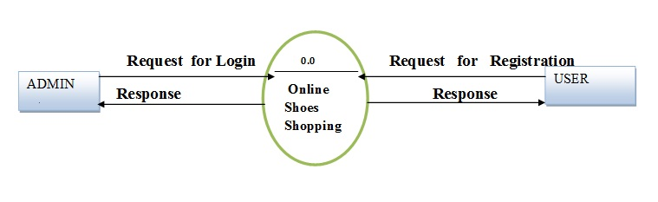

‎Level-1 Admin Side DFD

**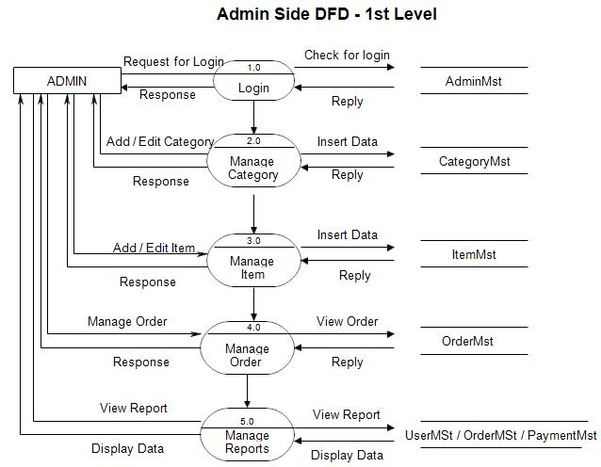**

‎2nd Level – Admin Side DFD

**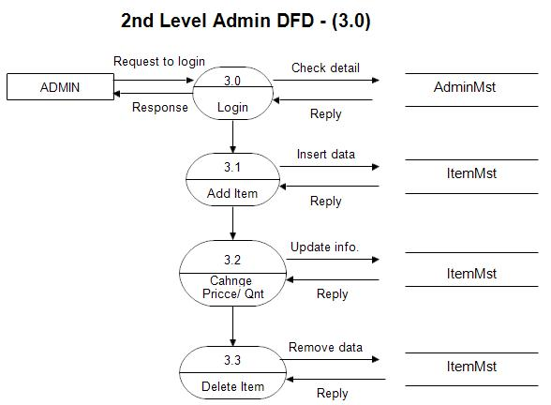**

‎Level-1 User side DFD

**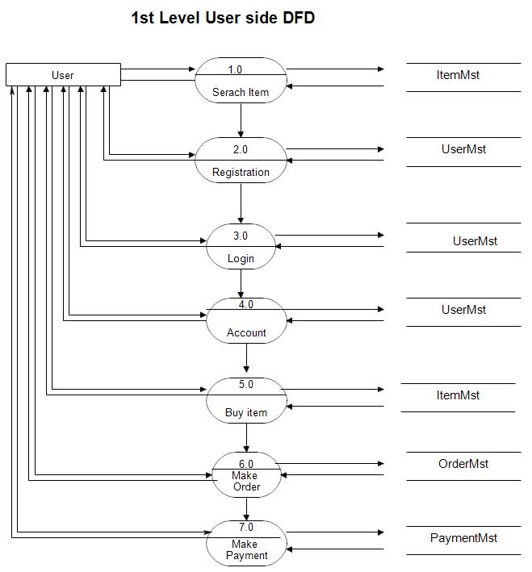**

‎Level-2 User side DFD

**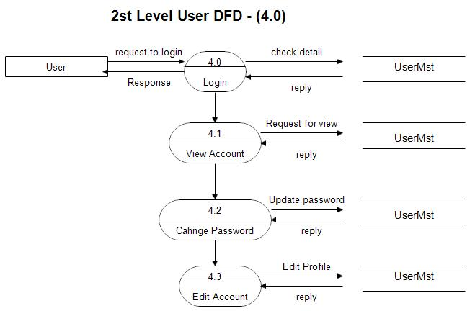**

Sequence Diagrams

Sequence diagrams capture the order of interactions between system components over time. For the e-commerce project, they can detail interactions between a customer, the website, and the database during actions like adding a product to the cart, initiating payment, and confirming the order.

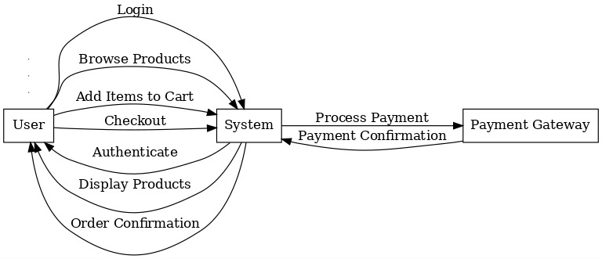

Use Case

Use case diagrams illustrate the functionalities of the system from a user perspective. In an e-commerce website, they can represent use cases like "Browse Products," "Add to Cart," "Make Payment," and "Track Order," showing the actors (users/admins) involved in each activity and their interactions.



Activity Diagrams

Activity diagrams show the dynamic workflows of a system. For an e-commerce website, they can represent processes like the order placement workflow, where users select products, add them to the cart, input delivery details, make payments, and receive confirmation.

Activity Flow associated with the system administrator

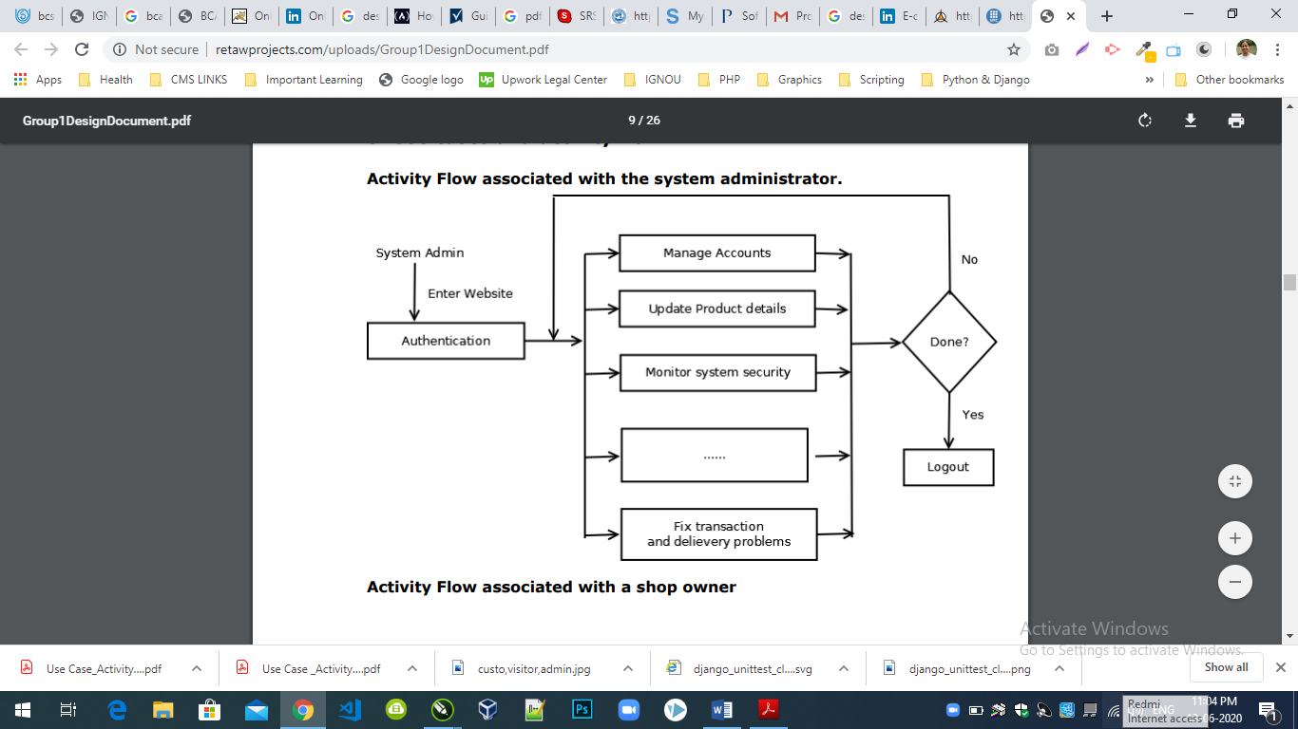

Activity Flow associated with a registered user

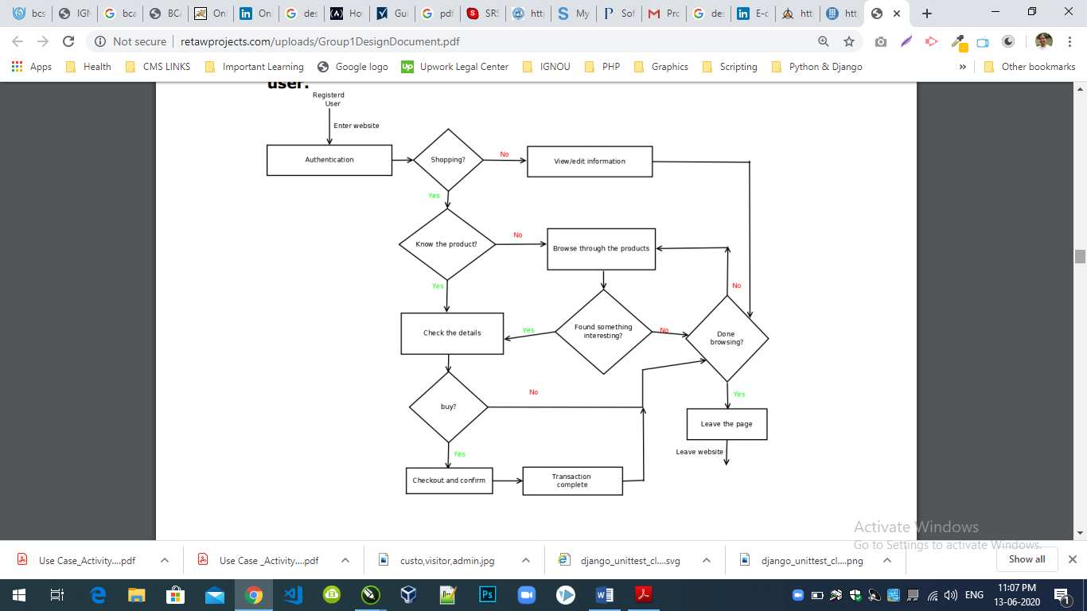

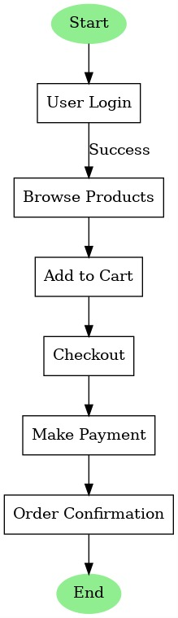

In this the process Starts from the beginning then we login with User Login credentials if it is successful we will Browse for the products and Add the items to the cart then the items will be sent to checkout and after doing the payment our order confirmation is done and it’s done at the End.

If the process starts and User Login credentials aren’t satisfied then we will try again.

If trying again gives same result then we will use correct login credentials for the user.

State Diagrams

State diagrams represent the various states an object in the system can have and how transitions occur between them. For instance, in an e-commerce website, the order object can transition between states such as "Pending," "Processing," "Shipped," and "Delivered" based on user and system actions.

Communication Diagrams

Communication diagrams show the interaction between objects or components of the system in terms of message exchange. For the e-commerce project, they can represent the communication between the user interface, the backend server, and the database during tasks like product retrieval or payment processing.

Deployment Diagrams

Deployment diagrams illustrate the physical deployment of software components onto hardware. For an e-commerce website hosted on AWS, the diagram would show components like the web server, application server, database server, and their deployment on AWS EC2 instances, with connections to services like S3 and Route 53.

Database Design

Database design focuses on creating structured schemas to efficiently store and retrieve data. For the e-commerce project, this includes designing tables for users, products, orders, and transactions, along with defining relationships such as one-to-many (users to orders) or many-to-many (products in orders) to ensure smooth data operations.

**Category Table**

|  |  |  |
| --- | --- | --- |
| Field | Type | Constraint |
| ID | Number(5) | Primary Key |
| Name | VarVarchar (50) | Not Null |
| Description | Text Field |  |
| Image | Image |  |

**Products Table**

|  |  |  |
| --- | --- | --- |
| Field | Type | Constraint |
| ID | Number(5) | Primary Key |
| Name | VarVarchar (50) | Not Null |
| Description | Text Field | Not Null |
| Price | Decimal | Not Null |
| Image | Image |  |
| Stock | Number |  |
| Available | Boolean |  |
| Created | Date Time Filed |  |

**Orders Table**

|  |  |  |
| --- | --- | --- |
| Field | Type | Constraint |
| ID | Number(5) | Primary Key |
| Total | Deccimal | Not Null |
| Email | Email | Not Null |
| Created | Date Time Field | Not Null |
| Product | VarVarchar (50) |  |
| Quantity | Number |  |
| Name | VarVarchar (50) |  |
| Address | VarVarchar (50) |  |
| City | VarVarchar (50) |  |
| Country | VarVarchar (50) |  |
| Postal Code | Number |  |

**User Registration Table**

|  |  |  |
| --- | --- | --- |
| Field | Type | Constraint |
| ID | Number(5) | Primary Key |
| Email | VarVarchar (50) | Not Null |
| Name | VarVarchar (50) | Not Null |
| Password | VarVarchar (50) | Not Null |
| Contact | Number | Not Null |

E-R Diagram

An Entity-Relationship (ER) diagram is a critical tool in database design, providing a graphical representation of the system's data and the relationships between entities. It is an essential step in creating a robust database structure, ensuring all system requirements are captured efficiently. ER modeling was introduced by Peter Chen in 1976 and has evolved significantly, with modern approaches incorporating advanced concepts like inheritance, generalization-specialization, and enhanced modeling tools.

In the context of an e-commerce website, an ER diagram is invaluable for mapping entities such as Users, Products, Orders, and Payments. Each entity represents a real-world object or concept, and the relationships between them—such as "User places Order" or "Order contains Product"—are depicted using connectors. Attributes, such as a user's email or a product's price, further enrich the model by adding details to each entity.

The latest advancements in ER modeling integrate support for NoSQL databases and hybrid schemas to cater to the growing demand for flexible and scalable systems. Tools like MySQL Workbench, Lucidchart, and ER/Studio now provide enhanced functionalities such as real-time collaboration, auto-generation of schema code, and support for cloud-based deployments.

For an e-commerce system, the ER diagram typically includes:

**User:** Attributes like User\_ID, Name, Email, and Password.

**Product:** Attributes such as Product\_ID, Name, Description, Price, and Stock.

**Order:** Attributes including Order\_ID, Order\_Date, and Total\_Amount.

**Payment:** Attributes like Payment\_ID, Payment\_Mode, and Transaction\_Status.

The relationships among these entities are designed to ensure data consistency and avoid redundancy. For instance, a one-to-many relationship exists between Users and Orders, as a single user can place multiple orders. Similarly, a many-to-many relationship connects Orders and Products since each order can include multiple products, and a product can appear in multiple orders. The ER diagram is not merely a theoretical design—it forms the backbone of database development. It ensures that the system aligns with the intended functionality, minimizes anomalies, and facilitates future scalability. With the advent of cloud-based databases and distributed systems, modern ER modeling now also considers factors like data partitioning, replication, and optimization for high-traffic environments. This approach ensures that the database design meets both current needs and potential future expansions.

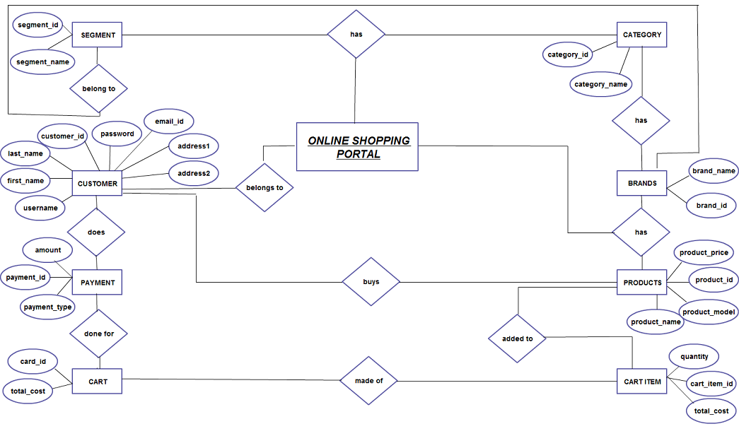

3.3 User Interface Design

The user interface (UI) of the e-commerce website is designed to provide a smooth, intuitive, and user-friendly experience for both customers and administrators. It ensures easy navigation, efficient browsing, and a seamless transaction process. Below are the main features of the UI design for different sections:

**For Customers:**

Home Page:

* Navigation bar with links to categories, search bar, user profile, cart, and help section.
* Featured products and categories with high-quality images.
* Banners showcasing promotions, offers, and discounts.
* Easy access to new arrivals, popular products, and limited-time deals.

Product Page:

* Product images with zoom-in functionality for better viewing.
* Product name, price, and a detailed description.
* Product specifications, including size, color, and other important attributes.
* Stock availability and shipping details.
* “Add to Cart” and “Buy Now” buttons.
* Product reviews and ratings from other customers.
* Related products and suggestions for further browsing.

Shopping Cart:

* List of added products with their images, names, quantities, and prices.
* Options to modify cart items (change quantity, remove items).
* Display of total cost, taxes, and shipping fees.
* Checkout button to proceed with the order.
* Option to save the cart for later or continue shopping.

Checkout Page:

* Form for customers to enter billing and shipping information.
* Summary of the products in the cart, including quantity and pricing details.
* Multiple payment options, including credit/debit cards, cash on delivery, or online payment gateways.
* Option to apply discount codes or promotional offers.
* Order confirmation and final review before completing the purchase.

Order Confirmation:

* Order number and summary of purchased items.
* Estimated delivery date and shipping method.
* A thank-you message with instructions for tracking the order.
* Option to view order history or continue shopping.

User Profile:

* Personal information management, including name, email, phone number, and address.
* View and manage order history and track previous orders.
* Manage payment methods and shipping addresses.
* Option to update password and communication preferences.

Search Functionality:

* A prominent search bar to search for products by name, category, or brand.
* Filters to refine search results based on product type, price, ratings, etc.
* Auto-suggestions and autocomplete features for faster browsing.

Account Registration and Login:

* Easy registration process for new users with email and password setup.
* Social media login options (e.g., Google, Facebook).
* Password recovery options for existing users.
* User-friendly login page to access personal accounts.

Order History:

* A list of previous orders with details such as products purchased, dates, prices, and order status.
* Option to repeat an order or view specific details of past purchases.

Product Comparison:

* Option to compare multiple products side-by-side based on features, prices, and specifications.

Contact Us:

* Contact form for inquiries, support, or feedback.
* Display of company contact details such as phone numbers, emails, and physical addresses.
* Integration of live chat or chatbot for instant customer support.

Help/FAQ Section:

* Frequently asked questions covering various aspects of the e-commerce site (payment, shipping, returns).
* Tips and guides for using the website, managing orders, and tracking deliveries.

**For Admins:**

Admin Dashboard:

* Overview of site activities, including total sales, number of orders, and active users.
* Quick links to key functions like product management, order management, and customer support.
* System notifications for low stock, pending orders, or customer inquiries.

Product Management:

* Interface to add, edit, or delete products.
* Manage product details such as name, description, price, images, and specifications.
* Set stock levels and manage inventory.
* Manage categories and product attributes.

Order Management:

* View and manage customer orders, including order status (pending, shipped, delivered).
* Option to cancel, update, or refund orders.
* Track payment statuses and shipping details.

Customer Management:

* View customer profiles, including their contact details, order history, and preferences.
* Manage customer support tickets and inquiries.
* Send promotional offers or updates to customers.

Report Generation:

* Generate sales reports, including total sales, revenue, and customer trends.
* Delivery and shipping reports, including pending deliveries, delivery statuses, and courier details.
* Customer behavior reports, including frequent purchases, order frequency, and product preferences.

Payment and Transaction Management:

* View all transactions and payment details.
* Process refunds or adjustments to payments.
* Generate invoices and receipts for customers.

Content Management:

* Manage promotional banners, product highlights, and offers.
* Update the homepage layout and other content sections (blogs, testimonials).
* Manage SEO-related content, such as product descriptions and keywords.

Security and User Access Control:

* Define admin roles and permissions for different users (view, edit, delete).
* Implement security measures to protect sensitive customer and transaction data.

Mobile Responsiveness:

* The UI is designed to be fully responsive, adapting seamlessly to mobile devices with touch-friendly buttons and optimized layouts. The mobile version of the website will provide all features found in the desktop version, ensuring a smooth shopping experience for mobile users.

3.4 Methodology

The methodology followed in the development of the e-commerce website is Agile Development, particularly using the Scrum Framework. Agile is chosen due to its iterative nature, allowing for flexibility and continuous client feedback integration, ensuring the project stays on track and adapts to changing requirements.

**Development Phases:**

Requirement Gathering and Analysis:

* Initial meetings with stakeholders to gather and analyze requirements.
* Detailed discussion on features, functionality, and design expectations.
* Creation of user stories and use cases for the development process.

Design Phase:

* Creation of wireframes, UI mockups, and database schema.
* Design of the system architecture, considering scalability and performance.
* Selection of development tools and frameworks.

Implementation Phase:

* Development of features in short, time-boxed iterations (Sprints).
* Continuous integration of functionalities such as product management, shopping cart, payment systems, etc.
* Regular meetings for task assignments, progress updates, and adjustments.

Testing Phase:

* Comprehensive testing (unit testing, integration testing, and user acceptance testing).
* Bug tracking and fixing.
* Security testing to ensure the website is protected from potential threats.

Deployment and Maintenance:

* Deployment of the website to the production environment.
* Ongoing monitoring of the system for performance and bug fixes.
* Regular updates, including new features, bug fixes, and optimizations based on user feedback.

Scrum Framework:

* Sprint Planning: A Sprint typically lasts 2-4 weeks, with specific goals and tasks defined for each Sprint. The Product Owner prioritizes tasks, and the team works on delivering functional features by the end of the Sprint.
* Daily Standups: Daily 15-minute meetings to discuss progress, challenges, and next steps. This ensures constant communication and quick issue resolution.
* Sprint Review: At the end of each Sprint, the team presents the developed features to the stakeholders, demonstrating the functionality and gathering feedback.
* Sprint Retrospective: After each Sprint, the team evaluates the process, identifies areas for improvement, and adjusts strategies for future Sprints.

**HOME PAGE**

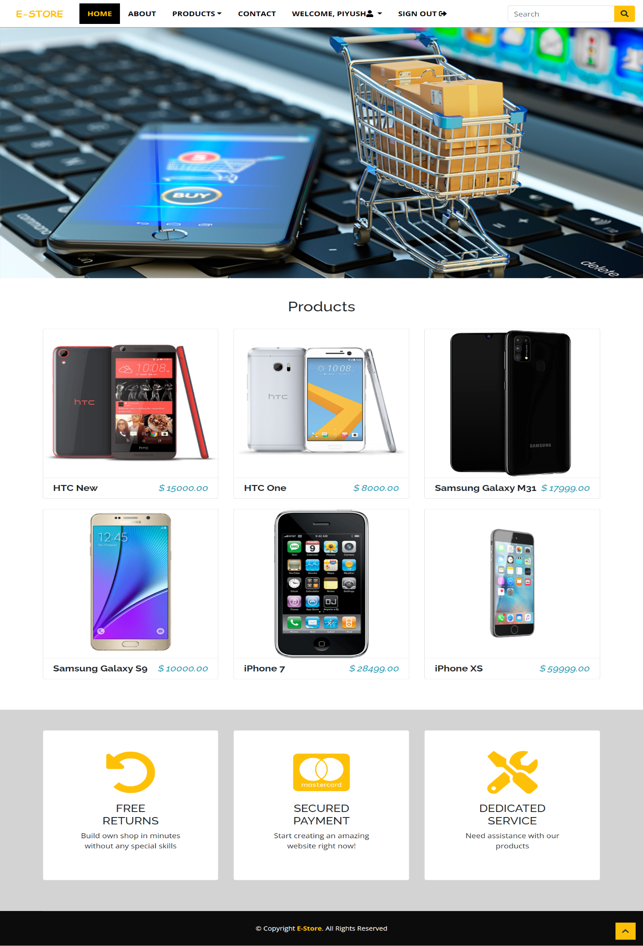

**ABOUT PAGE**

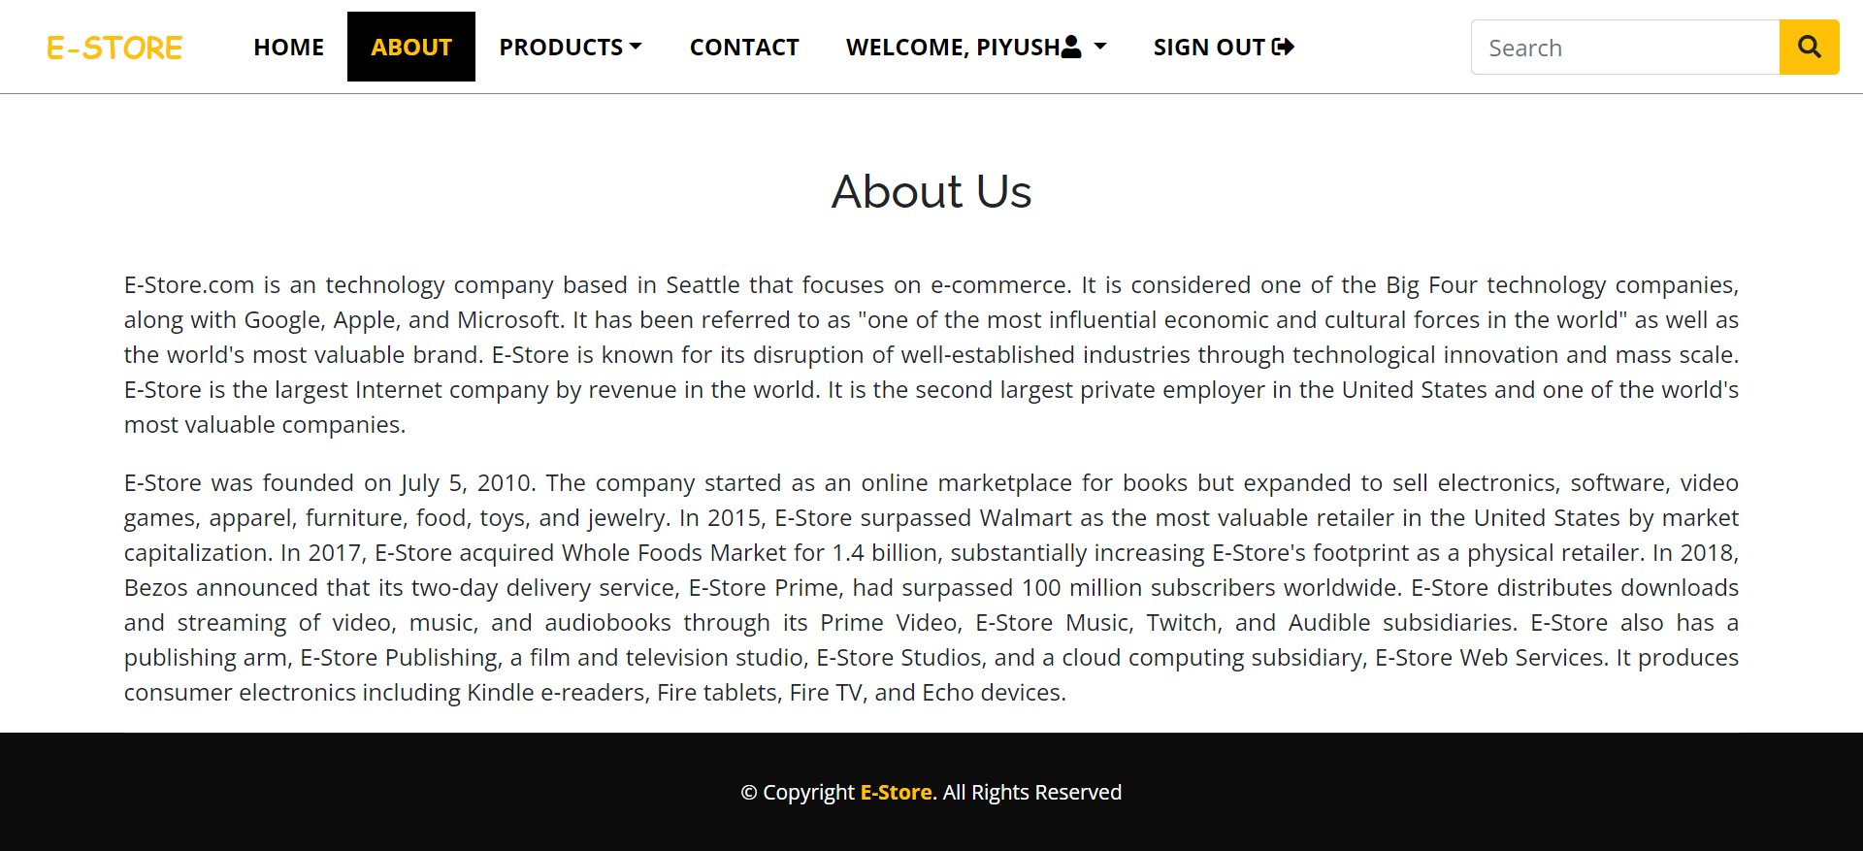

**PRODUCT DETAILS PAGE**

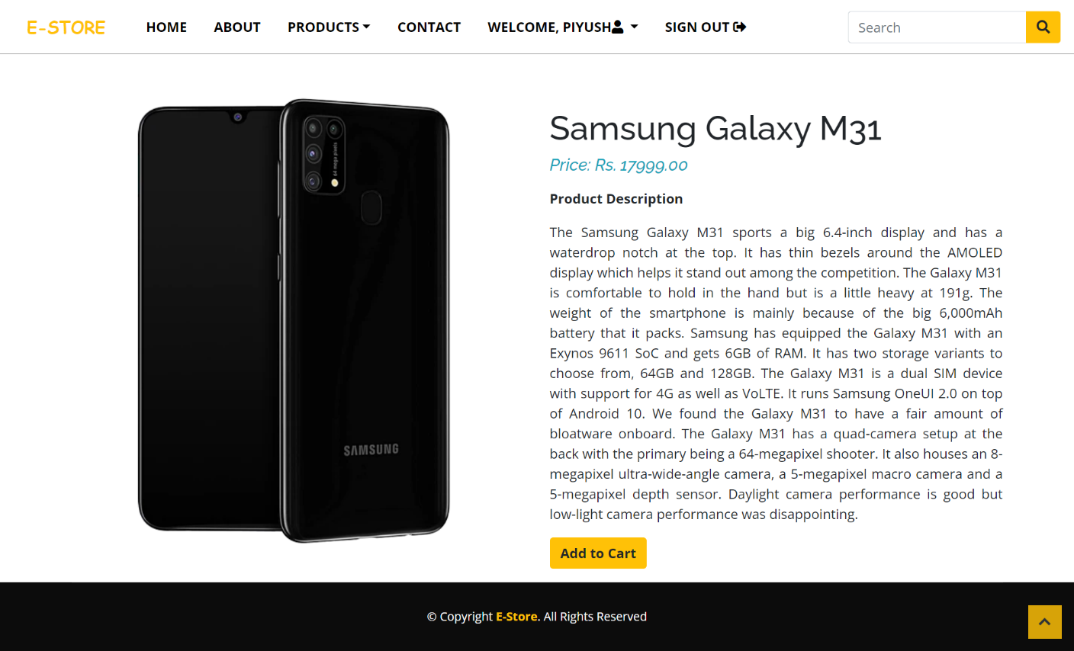

**CART PAGE**

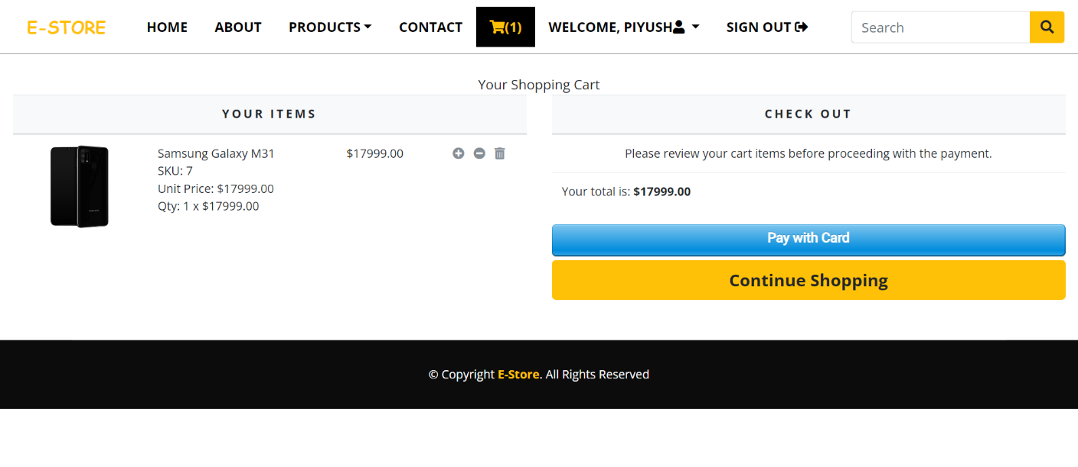

**ORDER PAYMENT PROCESS PAGE**

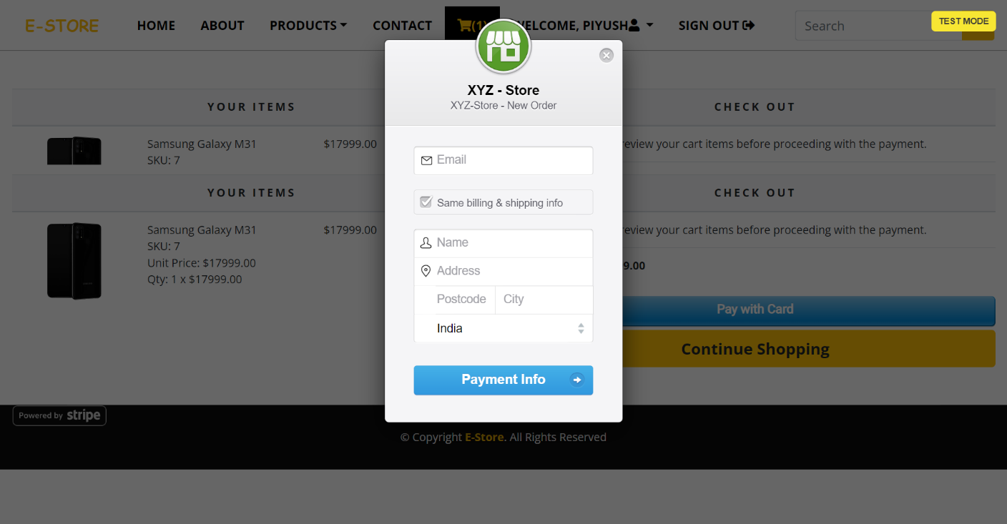

**THANK YOU PAGE**

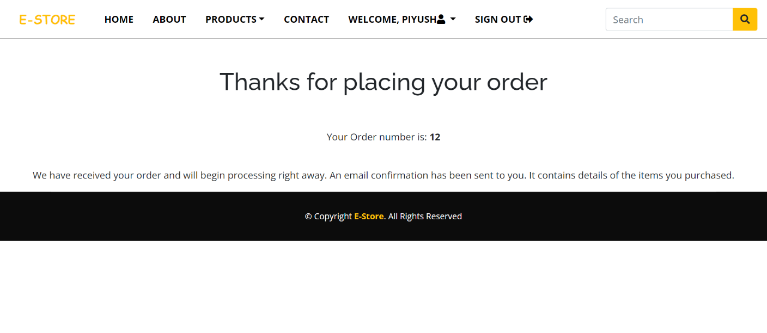

**CONTACT PAGE**

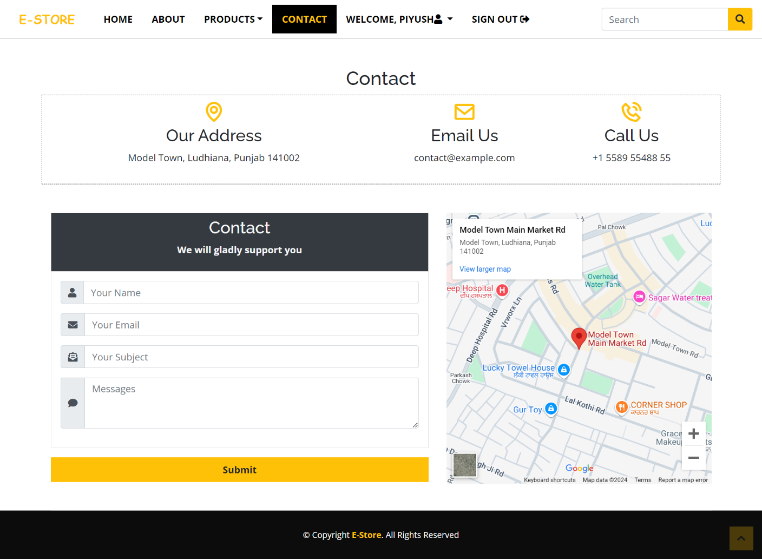

**USER ORDER HISTORY PAGE**

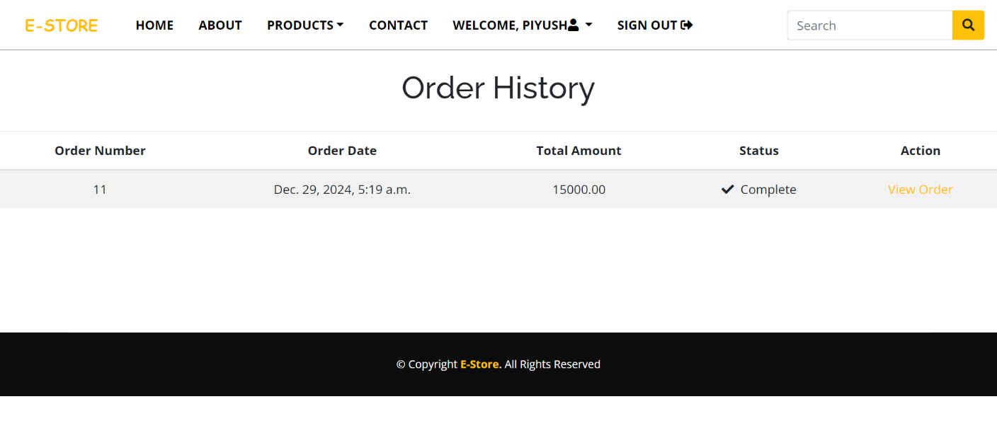

**INVOICE PAGE**

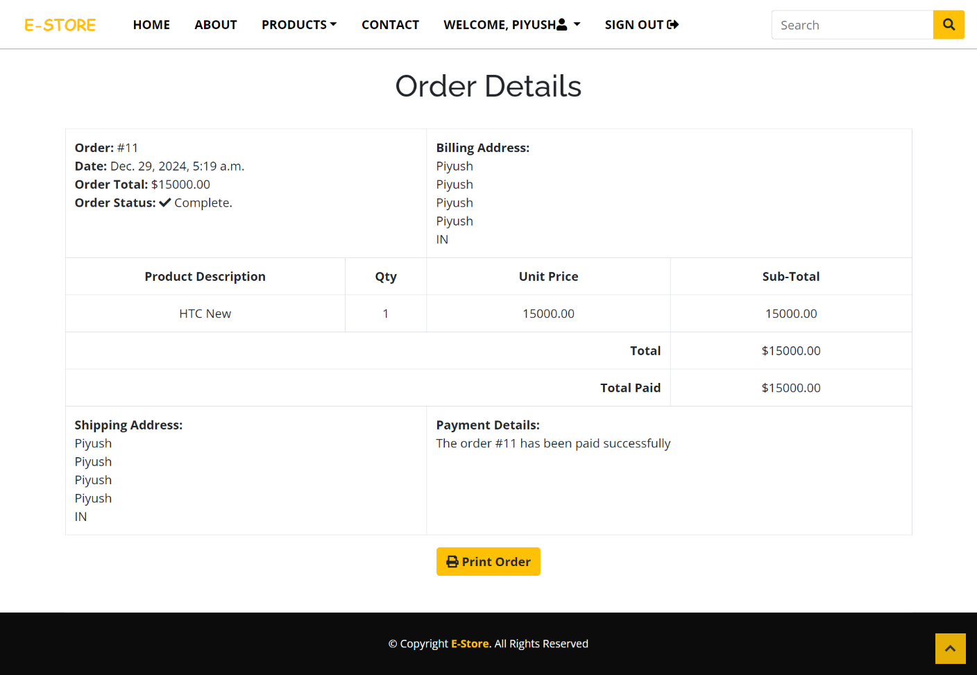

**SIGNIN PAGE**

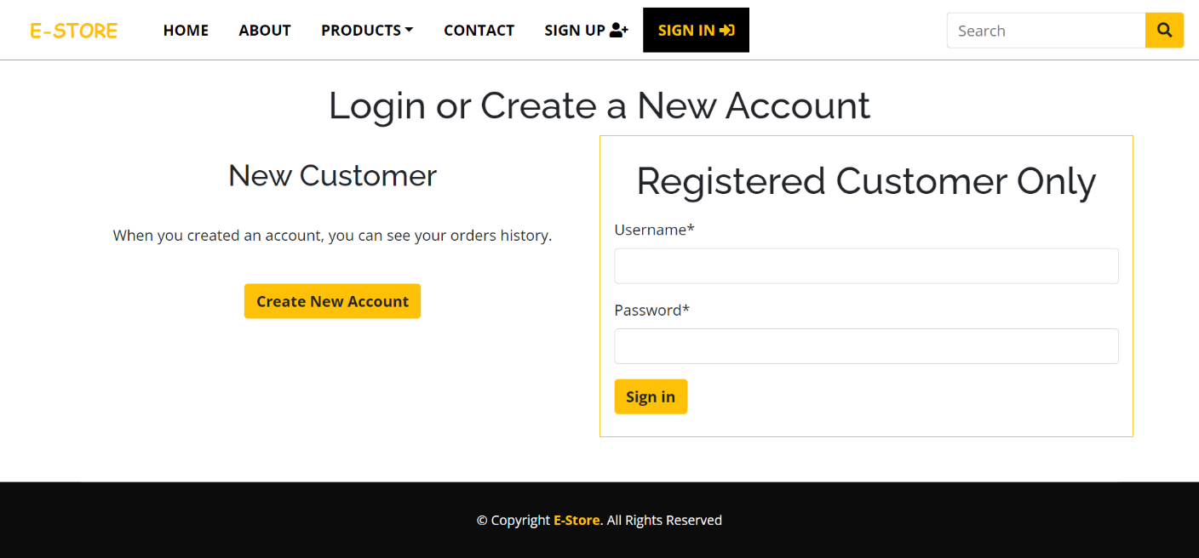

**SINGUP PAGE**

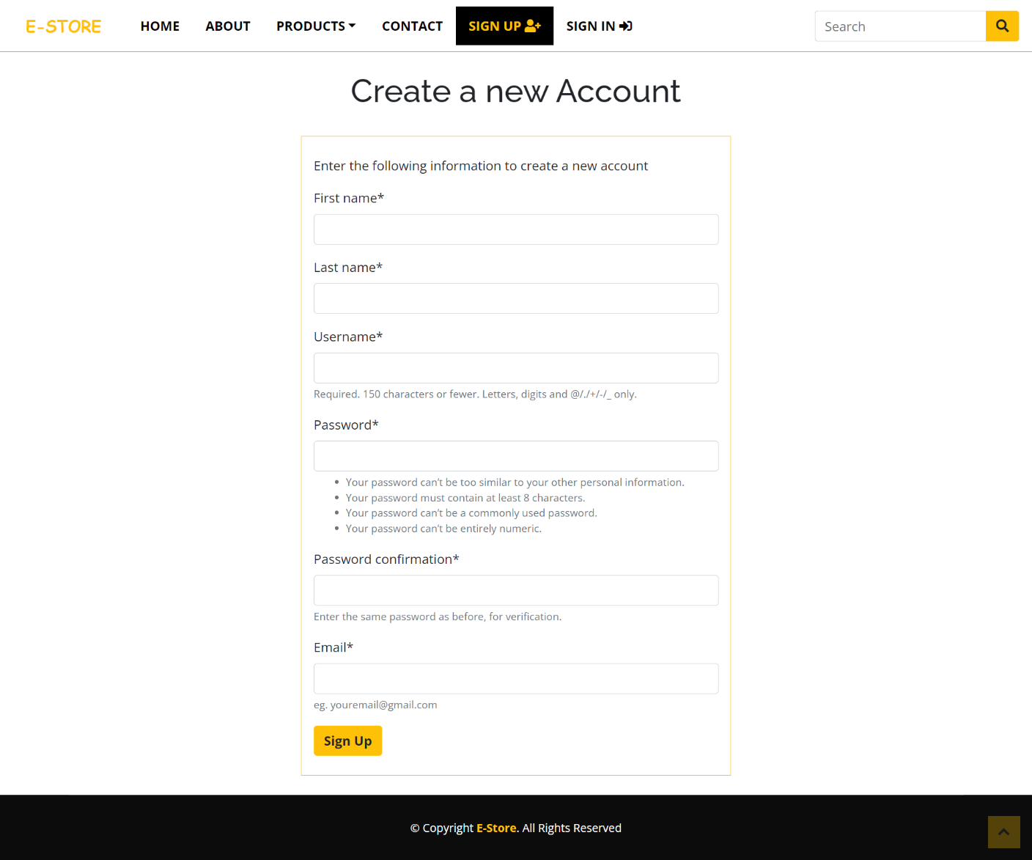

**BACKEND INTERFACE**

**ADMIN PRODUCTS TABLE**

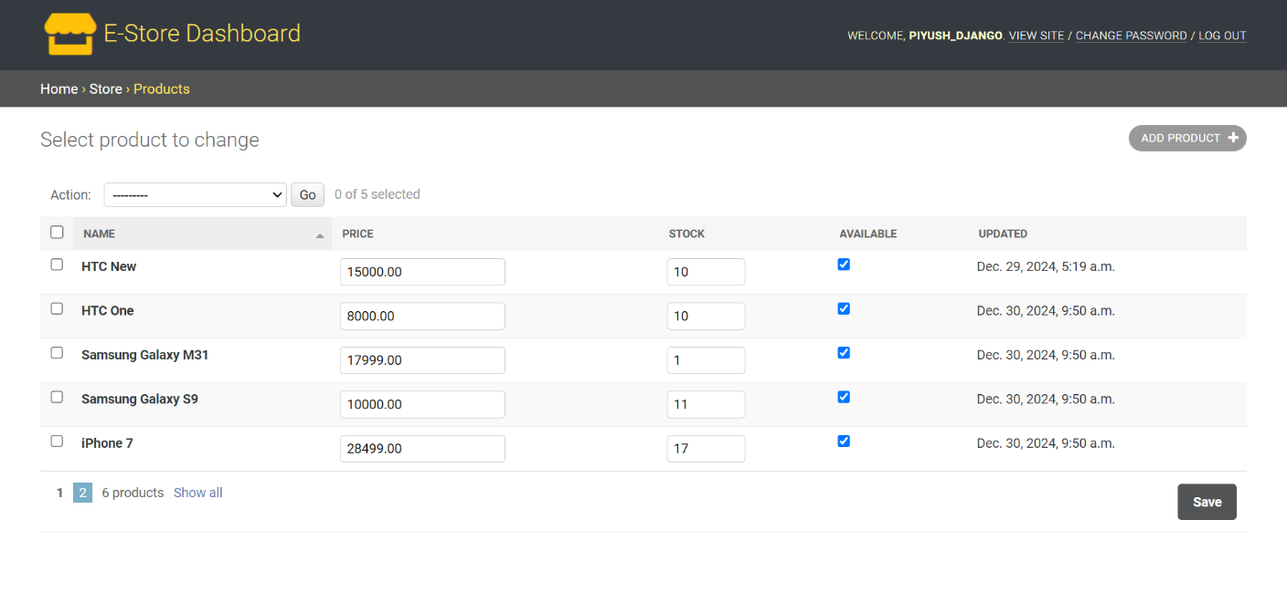

**ADMIN CATEGORY TABLE**

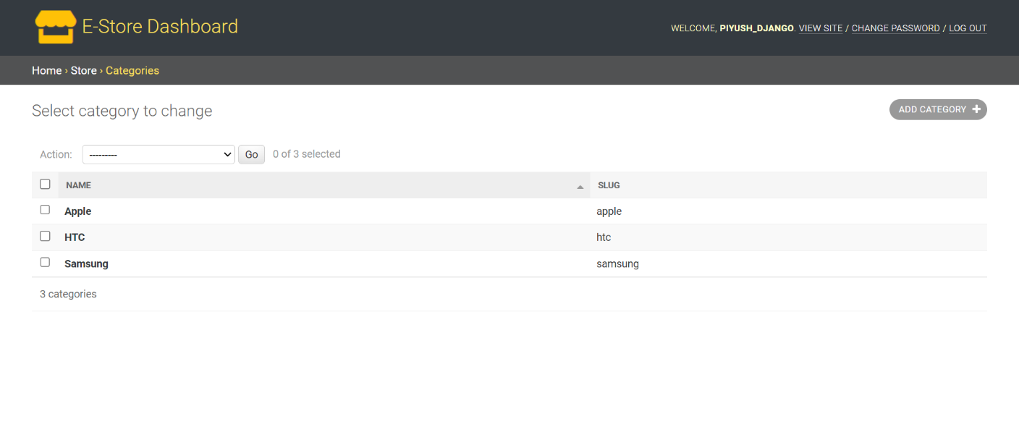

**ADMIN ORDERS TABLE**

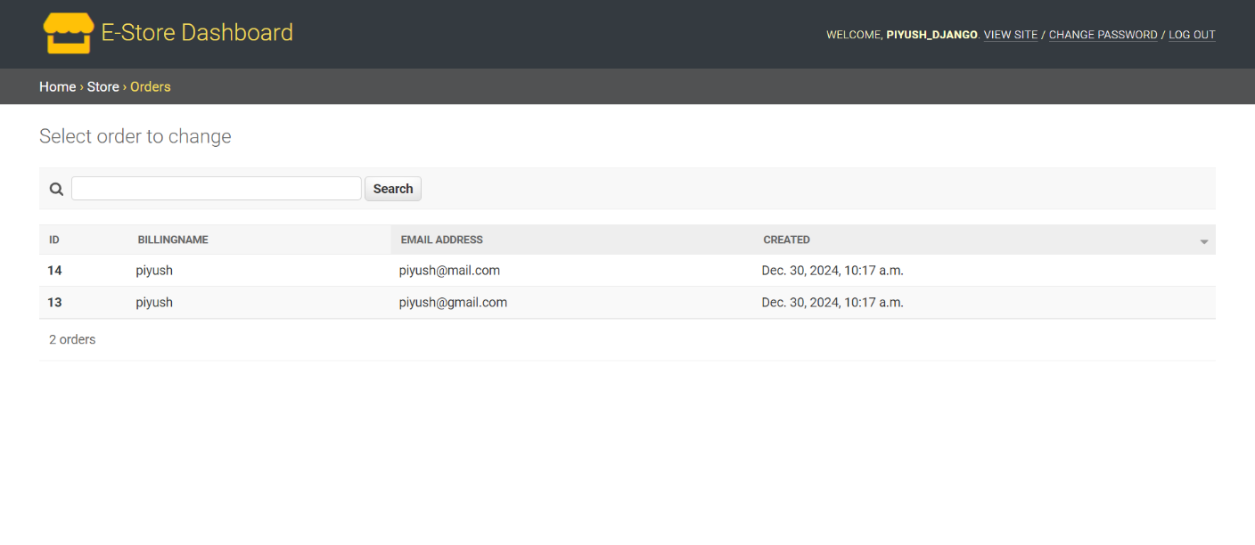

**ADMIN USER TABLE**

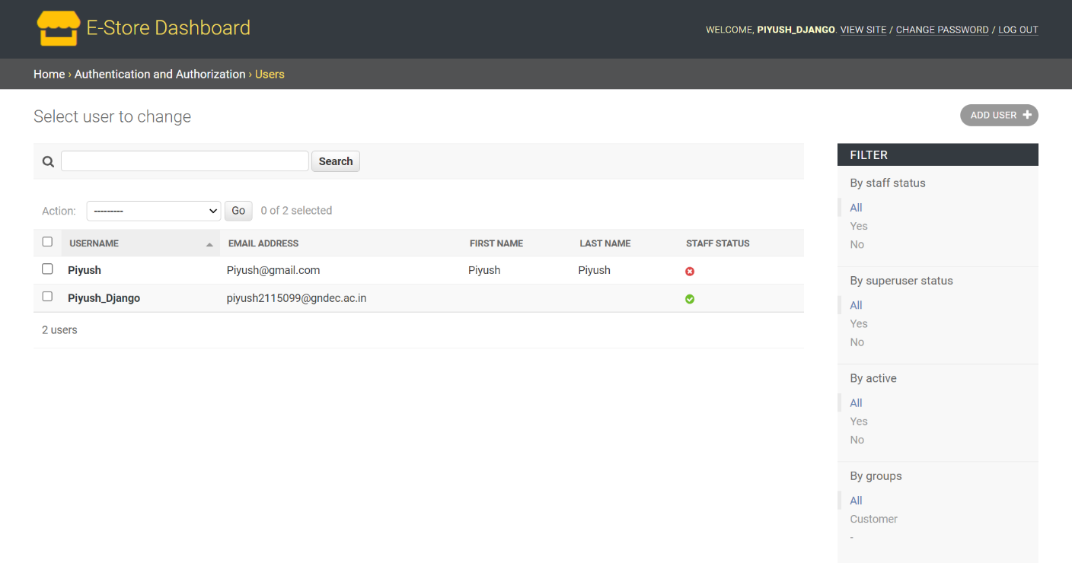

**Chapter 4: Implementation and Testing**

4.1 Introduction to Languages, IDE’s, Tools, and Technologies Used for Project Work

For the development of the e-commerce website, the following technologies and tools are utilized:

* Languages:
* HTML5: For structuring the web pages and creating the layout of the site.
* CSS3: For styling and responsive design, ensuring the website is aesthetically pleasing and works across various devices.
* JavaScript: For client-side scripting to handle interactive elements such as the shopping cart, user login, product search, and more.
* PHP: For server-side scripting to handle user authentication, product management, and transactions.
* SQL: For database management and handling customer, product, and order data.
* IDE (Integrated Development Environments):
* Visual Studio Code: A lightweight but powerful code editor used for writing HTML, CSS, JavaScript, PHP, and SQL. It has a large selection of extensions to aid in efficient coding.
* PHPStorm: Primarily used for PHP development, providing an advanced feature set like debugging, code completion, and integration with databases.
* Database Management System:
* MySQL: Used for storing and managing data such as user details, product information, and transaction records.
* Web Server:
* Apache: A popular open-source web server used to serve the website to users and run PHP scripts.
* Version Control:
* Git: Used for version control, ensuring that changes to the codebase are tracked and managed efficiently.
* GitHub: Used for hosting the code repository and collaborating with the development team.

Other Tools:

* Postman: Used for testing the APIs, ensuring correct responses are returned.

Cloud Hosting with Amazon AWS

The e-commerce website is hosted on Amazon Web Services (AWS) to ensure scalability, reliability, and high performance. The following AWS services are utilized:

Amazon EC2 (Elastic Compute Cloud):

* Provides virtual servers (instances) for hosting the website.
* Ensures flexibility in scaling the infrastructure up or down based on the website traffic.
* Offers robust performance and control over server configurations.

Amazon S3 (Simple Storage Service):

* Used for storing and managing static files such as product images, videos, and other media files.
* Provides high durability and availability for large amounts of data.

Amazon RDS (Relational Database Service):

* Hosts the MySQL database in a managed environment.
* Handles backups, patching, and scaling for optimal database performance.

AWS CloudFront:

* A Content Delivery Network (CDN) that speeds up the delivery of static and dynamic content by caching data at edge locations worldwide.
* Ensures a low-latency experience for users across the globe.

AWS IAM (Identity and Access Management):

* Ensures secure access management for AWS resources.
* Defines user roles and permissions for safe collaboration among developers.

AWS Elastic Load Balancer (ELB):

* Distributes incoming traffic across multiple EC2 instances, ensuring high availability and fault tolerance.

AWS Auto Scaling:

* Automatically adjusts the number of EC2 instances to handle varying traffic levels.
* By integrating AWS services, the e-commerce website benefits from a highly scalable, secure, and cost-effective hosting environment. This ensures uninterrupted performance, even during peak traffic, while keeping data secure and accessible.

The e-commerce website is hosted on Amazon Web Services (AWS), utilizing the following AWS services:

**Amazon EC2 (Elastic Compute Cloud):** Provides scalable computing capacity to run the website on virtual servers. EC2 allows for easy scaling based on traffic demand.

**Amazon S3 (Simple Storage Service):** Used for storing static assets such as images, product details, and other media files. S3 provides high availability and durability for these resources.

The website can be accessed using its public IP address, offering direct access to the application without the need for a domain name. This is useful for internal testing, development, or situations where a custom domain may not be set up yet.

4.2 Algorithm/Pseudocode Used

Below is a sample pseudocode for implementing the user login system for the e-commerce website.

START

INPUT username, password

IF username exists in database THEN

FETCH stored\_password from database

IF password matches stored\_password THEN

DISPLAY "Login Successful"

STORE session for user

REDIRECT to home page

ELSE

DISPLAY "Invalid Password"

END IF

ELSE

DISPLAY "Username not found"

END IF

END

4.3 Testing Techniques: In Context of Project Work

Testing is a crucial phase of the project to ensure that the e-commerce system is functioning correctly. The following testing techniques were employed:

**Unit Testing:**

* Each individual component (e.g., login system, product search, checkout process) was tested in isolation to ensure that it behaves as expected. Unit tests were written using PHPUnit for PHP.

**Integration Testing:**

* Integration testing was performed to check if different modules of the system (such as login, product search, and cart management) work together seamlessly. This ensures that the data flows correctly between modules.

**Functional Testing:**

* Functional testing was done to verify that the system meets the business requirements, including verifying user registration, login, product search, order placement, and payment transactions.

**Usability Testing:**

* A group of users tested the e-commerce website for user-friendliness, navigation, and overall experience. Feedback was collected to improve the website's design and interaction flow.

**Performance Testing:**

* The website was tested under different loads to measure its response time, scalability, and stability. Tools like JMeter were used to simulate multiple users accessing the website simultaneously.

**Security Testing:**

* Security testing was conducted to ensure there are no vulnerabilities like SQL injection, XSS (cross-site scripting), or CSRF (cross-site request forgery). OWASP ZAP was used for security vulnerability scanning.

**Acceptance Testing:**

* The final testing phase where the e-commerce system was tested by the client to ensure it meets all the business requirements and is ready for deployment.

4.4 Test Cases Designed for the Project Work

The following test cases were designed to validate various functionalities of the e-commerce website:

* Test Case 1: User Registration

**Objective:** Ensure that a new user can successfully register on the site.

**Steps:**

1. Navigate to the registration page.
2. Enter valid username, password, email, and other required details.
3. Click the “Register” button.
4. Expected Result: User is successfully registered, and a confirmation email is sent.

* Test Case 2: User Login

**Objective:** Ensure that an existing user can successfully log in.

**Steps:**

1. Navigate to the login page.
2. Enter valid username and password.
3. Click the “Login” button.
4. Expected Result: User is successfully logged in and redirected to the homepage.

* Test Case 3: Product Search

**Objective:** Ensure the search functionality returns relevant products.

**Steps:**

1. Navigate to the search bar.
2. Enter a product name or keyword.
3. Click the search icon.
4. Expected Result: Relevant products related to the search term are displayed.

* Test Case 4: Add to Cart

**Objective:** Ensure that users can add products to the shopping cart.

**Steps:**

1. Browse the product catalog.
2. Select a product and click the "Add to Cart" button.
3. Expected Result: Product is added to the shopping cart, and the cart icon is updated with the correct count.

* Test Case 5: Checkout and Payment

**Objective:** Ensure that the checkout process and payment gateway work correctly.

**Steps:**

1. Go to the shopping cart and review the selected products.
2. Click "Proceed to Checkout."
3. Enter shipping and payment information.
4. Confirm the order.
5. Expected Result: User is redirected to a confirmation page with order details.

* Test Case 6: Order History

**Objective:** Ensure that the user can view their order history.

**Steps:**

1. Log in as a registered user.
2. Navigate to the “Order History” section.
3. Expected Result: The list of past orders is displayed with details like product name, quantity, and status.

* Test Case 7: Security Check

**Objective:** Ensure that the login system is secure and does not allow SQL injection.

**Steps:**

1. Enter a SQL injection string in the username or password field (e.g., ' OR 1=1;--).
2. Click the “Login” button.
3. Expected Result: The system should reject the input and show an error message indicating invalid login.

This chapter ensures that the e-commerce website is developed and tested thoroughly to meet the specified requirements and deliver a functional, secure, and reliable system.

**Chapter 5: Results and Discussions**

5.1 User Interface Representation (of Respective Project)

The e-commerce website's user interface has been meticulously designed to provide a seamless and engaging experience for users. The UI includes modules for browsing products, managing accounts, and completing purchases. Each module is optimized for clarity, responsiveness, and ease of use, ensuring users can efficiently navigate and complete their tasks.

5.1.1 Brief Description of Various Modules of the System

1. **Home Page**

The home page serves as the gateway to the e-commerce platform. It includes prominently displayed banners showcasing featured products, trending items, and ongoing offers or discounts. Users can browse highlighted categories, including electronics, clothing, and accessories, directly from the homepage. A search bar is available at the top to allow users to quickly find products by typing keywords. The home page also displays user account links for logging in or registering and quick links to the shopping cart and customer service.

1. **Login/Registration Module**

The login and registration module enables users to authenticate their accounts. New users can register by providing details like username, email, and password. Registered users can log in with their credentials. The module includes a password recovery option to retrieve forgotten credentials. A confirmation email is sent upon successful registration to validate user accounts. The login page redirects authenticated users to their account dashboard.

1. **Product Catalog**

The product catalog allows users to browse through a variety of products organized into categories and subcategories. Each product is displayed with its image, name, price, and rating. Users can filter products based on criteria like price range, brand, and rating or sort them by popularity, relevance, or price (ascending/descending). Clicking on a product redirects users to the product details page, which provides a comprehensive description, specifications, and customer reviews.

1. **Product Details Page**

This module provides an in-depth view of individual products. It includes a high-resolution image gallery, detailed product specifications, pricing information, and customer reviews. Users can view ratings and leave reviews for products they have purchased. An "Add to Cart" button allows users to save the product for purchase.

1. **Shopping Cart**

The shopping cart module displays a list of products that the user has added for purchase. Each item in the cart includes the product name, price, quantity, and subtotal. Users can update quantities or remove items from the cart. The cart also displays the total cost, including applicable taxes and shipping fees. From here, users can proceed to checkout or continue shopping.

1. **Checkout and Payment Module**

The checkout module guides users through the payment process. It collects shipping details, such as the recipient's name, address, and contact information. Payment options include cash on delivery, credit card, debit card, and UPI. The module integrates with secure payment gateways to process transactions. A confirmation page summarizes the order and displays a unique order ID for tracking purposes.

1. **Order History and Tracking Module**

Registered users can access their order history, which lists all previous purchases. Each order includes the product details, total cost, and delivery status. Users can track the status of current orders in real-time, with updates such as "Order Placed," "Shipped," and "Delivered."

1. **Admin Panel**

The admin panel is designed for administrators to manage the e-commerce website. It includes functionalities to add, update, or remove products, monitor orders, and review customer feedback. Admins can also generate sales reports and manage promotional campaigns directly from the panel.

1. **Customer Support Module**

This module provides users with options to contact customer service for queries or issues. Features include a contact form, an FAQ section, and a chatbot for instant assistance. Users can also submit tickets for unresolved issues, which are managed by the support team.

1. **Feedback and Reviews Module**

Users can leave feedback on their shopping experience and review purchased products. The reviews are displayed publicly on product pages, while feedback is used to improve the platform.

5.2 Snapshots of System with Brief Detail of Each and Discussion

Snapshots will include key screens of the system, such as:

* **Home Page:** Showcasing featured products and categories.
* **Login/Registration Page:** Allowing users to create or access accounts.
* **Product Catalog:** Displaying product listings with filters and sorting options.
* **Shopping Cart:** Displaying selected items, quantities, and total cost.
* **Checkout Page:** Collecting payment and shipping details.

Each snapshot will include annotations and descriptions highlighting the functionality and design approach.

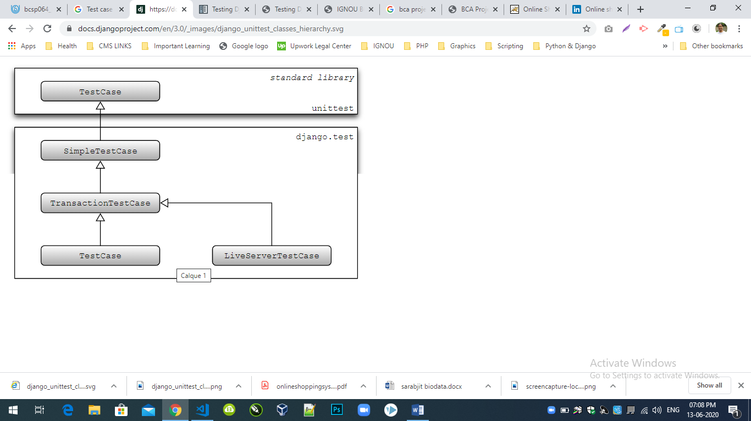

5.3 Back-End Representation (if Database has been used)

The database is used to store and manage all critical data for the e-commerce website, such as user accounts, product details, and transaction records.

5.3.1 Snapshots of Database Tables with Brief Description

Users Table:

* Columns: User ID, Username, Email, Password (hashed), Contact Info.
* Purpose: Stores registered user information securely.
* Products Table
* Columns: Product ID, Name, Category, Description, Price, Stock, Images.
* Purpose: Maintains details of all available products.

Orders Table:

* Columns: Order ID, User ID, Product ID, Quantity, Total Price, Status.
* Purpose: Tracks user orders and their statuses.
* Transactions Table
* Columns: Transaction ID, Order ID, Payment Method, Amount, Status.
* Purpose: Records payment details for each order.

Feedback Table:

* Columns: Feedback ID, User ID, Product ID, Rating, Comments.
* Purpose: Stores user reviews and feedback on products.
* Admin Table
* Columns: Admin ID, Username, Password (hashed).
* Purpose: Stores admin login credentials to manage the website.

Django Test Report

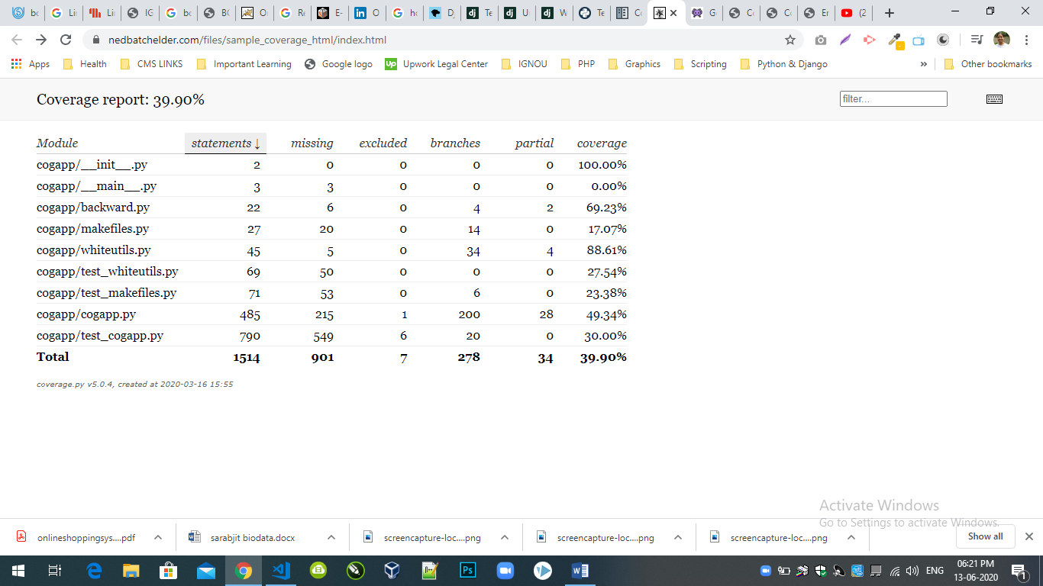

**Chapter 6: Conclusion and Future Scope**

The e-commerce platform developed as part of this project provides a comprehensive solution for online buying and selling. The system is equipped with robust functionalities, including user registration, product categorization, secure online transactions, cart management, order history, and feedback mechanisms. The implementation leverages modern technologies like Django, PostgreSQL, and responsive design frameworks like Bootstrap, ensuring a seamless and user-friendly experience for both customers and administrators. The integration of modular design principles ensures scalability, maintainability, and flexibility for future enhancements. Through rigorous testing, including unit, integration, and regression testing, the system has been validated to meet the requirements outlined in the Software Requirement Specification (SRS) document. The platform is designed to provide reliable and efficient performance, offering 24/7 availability and secure handling of sensitive customer data. In conclusion, this e-commerce project not only meets the objectives of providing a user-friendly and feature-rich shopping platform but also lays the foundation for future growth and innovation in the online retail space.

Future Scope:

The current e-commerce platform serves as a strong foundation for further development. Several enhancements can be considered to ensure the system evolves with market trends and user expectations:

* **Integration with Payment Gateways**:
* Expand beyond the current payment method to include popular payment gateways like PayPal, Stripe, and Razorpay, enabling a wider range of secure payment options.
* **AI-Powered Recommendations**:
* Implement machine learning algorithms to provide personalized product recommendations based on user behavior and purchase history.
* **Mobile Application**:
* Develop a dedicated mobile application for Android and iOS to enhance accessibility and usability on smartphones.
* **Chatbot Integration**:
* Introduce AI-driven chatbots to assist users in real-time, answering queries and guiding them through the shopping process.
* **Advanced Analytics**:
* Incorporate advanced analytics tools to provide detailed insights into customer behavior, sales trends, and marketing campaign effectiveness.
* **Vendor Dashboard**:
* Develop a dedicated dashboard for vendors to manage their products, pricing, and promotions, enabling a multi-vendor marketplace model.
* **Enhanced Security Measures**:
* Implement multi-factor authentication (MFA) and real-time fraud detection systems to ensure the highest level of security for user data and transactions.
* **Globalization Features**:
* Add multi-language and multi-currency support to cater to an international audience, facilitating cross-border e-commerce.

References/Bibliography:

1. **Framework and Languages**:

* Django Web Framework Documentation: <https://docs.djangoproject.com>
* PostgreSQL Database Official Documentation: <https://www.postgresql.org/docs>
* Bootstrap Framework: <https://getbootstrap.com>

1. **Testing Techniques**:

* Python unittest Library: <https://docs.python.org/3/library/unittest.html>
* Selenium Web Testing: <https://www.selenium.dev>

1. **Development Tools**:

* Visual Studio Code Documentation: <https://code.visualstudio.com/docs>
* HTML, CSS, and JavaScript Specifications: <https://developer.mozilla.org>

1. **Design Principles**:

* Modular Programming: IEEE Modular Programming Standards
* Object-Oriented Design: Grady Booch's Object-Oriented Analysis and Design with Applications

1. **Additional Resources**:

* Official Bootstrap Icons and Templates: https://icons.getbootstrap.com
* W3Schools Tutorials on Web Development: <https://www.w3schools.com>

1. **Testing Frameworks**:

* Django Testing Framework: <https://docs.djangoproject.com/en/3.2/topics/testing>
* Selenium Testing Suite: <https://selenium-python.readthedocs.io>

‎1.‎ [https://www.wikipedia.org/](https://www.wikipedia.org/" \t "_new)‎  
‎2.‎ <https://www.w3schools.com/>‎  
‎3.‎ <https://getbootstrap.com/>‎  
‎4.‎ <https://www.djangoproject.com/>‎  
‎5.‎ <https://www.python.org/>‎  
‎6.‎ <https://www.postgresql.org/>‎  
‎7.‎ <https://fontawesome.com/>‎  
‎8.‎ <https://michalsnik.github.io/aos/>‎  
‎9.‎ <https://stripe.com/en-in>  
‎10.‎ <https://www.quora.com/>

**HTML**

Hypertext Markup Language (HTML) is the standard mark-up language for documents designed to be displayed in a web browser. It can be assisted by technologies such as Cascading Style Sheets (CSS) and scripting languages such as JavaScript. Web browsers receive HTML documents from a web server or from local storage and render the documents into multimedia web pages. HTML describes the structure of a web page semantically and originally included cues for the appearance of the document. HTML elements are the building blocks of HTML pages. With HTML constructs, images and other objects such as interactive forms may be embedded into the rendered page. HTML provides a means to create structured documents by denoting structural semantics for text such as headings, paragraphs, lists, links, quotes and other items. HTML elements are delineated by tags, written using angle brackets. Tags such as <img /> and <input /> directly introduce content into the page. Other tags such as <p> surround and provide information about document text and may include other tags as sub-elements. Browsers do not display the HTML tags, but use them to interpret the content of the page. HTML can embed programs written in a scripting language such as JavaScript, which affects the behaviour and content of web pages. Inclusion of CSS defines the look and layout of content. The World Wide Web Consortium (W3C), former maintainer of the HTML and current maintainer of the CSS standards, has encouraged the use of CSS over explicit presentational HTML since 1997.

**CSS**

Cascading Style Sheets (CSS) is a style sheet language used for describing the presentation of a document written in a mark-up language like HTML. CSS is a cornerstone technology of the World Wide Web, alongside HTML and JavaScript.CSS is designed to enable the separation of presentation and content, including layout, colours and fonts. This separation can improve content accessibility, provide more flexibility and control in the specification of presentation characteristics, enable multiple web pages to share formatting by specifying the relevant CSS in a separate .css file, and reduce complexity and repetition in the structural content. Separation of formatting and content also makes it feasible to present the same mark-up page in different styles for different rendering methods, such as on-screen, in print, by voice (via speech-based browser or screen reader) and on Braille-based tactile devices. CSS also has rules for alternate formatting if the content is accessed on a mobile device.The name cascading comes from the specified priority scheme to determine which style rule applies if more than one rule matches a particular element. This cascading priority scheme is predictable. The CSS specifications are maintained by the World Wide Web Consortium (W3C). Internet media type (MIME type) text/css is registered for use with CSS by RFC 2318 (March 1998). The W3C operates a free CSS validation service for CSS documents.

**BOOTSTRAP**

Bootstrap is a free and open-source CSS framework directed at responsive, mobile-first front-end web development. It contains CSS- and (optionally) JavaScript-based design templates for typography, forms, buttons, navigation, and other interface components. Bootstrap is the sixth-most-starred project on GitHub, with more than 135,000 stars, behind freeCodeCamp (almost 307,000 stars) and marginally behind Vue.js framework. According to Alexa Rank, Bootstrap is in the top-2000 in the USA while vuejs.org is in the top-7000 in the USA. Bootstrap, originally named Twitter Blueprint, was developed by Mark Otto and Jacob Thornton at Twitter as a framework to encourage consistency across internal tools. Before Bootstrap, various libraries were used for interface development, which led to inconsistencies and a high maintenance burden. Bootstrap focuses on simplifying the development of informative web pages (as opposed to web apps). The primary purpose of adding it to a web project is to apply Bootstrap's choices of colour, size, font and layout to that project. As such, the primary factor is whether the developers in charge find those choices to their liking. Once added to a project,Bootstrap provides basic style definitions for all HTML elements. The result is a uniform appearance for prose, tables and form elements across web browsers. In addition, developers can take advantage of CSS classes defined in Bootstrap to further customize the appearance of their contents. For example, Bootstrap has provisioned for light- and dark-coloured tables, page headings, more prominent pull quotes, and text with a highlight. Bootstrap also comes with several JavaScript components in the form of jQuery plugins. They provide additional user interface elements such as dialog boxes, tooltips, and carousels. Each Bootstrap component consists of an HTML structure, CSS declarations, and in some cases accompanying JavaScript code. They also extend the functionality of some existing interface elements, including for example an auto-complete function for input fields.

**JAVASCRIPT**

JavaScript often abbreviated as JS, is a programming language that conforms to the ECMAScript specification. JavaScript is high-level, often just-in-time compiled, and multi-paradigm. It has curly-bracket syntax, dynamic typing, prototype-based object-orientation, and first-class functions. Alongside HTML and CSS, JavaScript is one of the core technologies of the World Wide Web. JavaScript enables interactive web pages and is an essential part of web applications. The vast majority of websites use it for client-side page behaviour and all major web browsers have a dedicated JavaScript engine to execute it. As a multi-paradigm language, JavaScript supports event-driven, functional, and imperative programming styles. It has application programming interfaces (APIs) for working with text, dates, regular expressions, standard data structures, and the Document Object Model (DOM). However, the language itself does not include any input/output (I/O), such as networking, storage, or graphics facilities, as the host environment (usually a web browser) provides those APIs. JavaScript engines were originally used only in web browsers, but they are now embedded in some servers, usually via Node.js. They are also embedded in a variety of applications created with frameworks such as Electron and Cordova. Although there are similarities between JavaScript and Java, including language name, syntax, and respective standard libraries, the two languages are distinct and differ greatly in design.

**JQUERY**

jQuery is a JavaScript library designed to simplify HTML DOM tree traversal and manipulation, as well as event handling, CSS animation, and Ajax. It is free, open-source software using the permissive MIT License. As of May 2019, jQuery is used by 73% of the 10 million most popular websites. Web analysis indicates that it is the most widely deployed JavaScript library by a large margin, having 3 to 4 times more usage than any other JavaScript library.jQuery's syntax is designed to make it easier to navigate a document, select DOM elements, create animations, handle events, and develop Ajax applications. jQuery also provides capabilities for developers to create plug-ins on top of the JavaScript library. This enables developers to create abstractions for low-level interaction and animation, advanced effects and high-level, theme able widgets. The modular approach to the jQuery library allows the creation of powerful dynamic web pages and Web applications. The set of jQuery core features—DOM element selections, traversal and manipulation—enabled by its selector engine (named "Sizzle" from v1.3), created a new "programming style", fusing algorithms and DOM data structures. This style influenced the architecture of other JavaScript frameworks like YUI v3 and Dojo, later stimulating the creation of the standard Selectors API. Later, this style has been enhanced with a deeper algorithm-data fusion in an heir of jQuery, the D3.js framework. Microsoft and Nokia bundle jQuery on their platforms. Microsoft includes it with Visual Studio for use within Microsoft's ASP.NET AJAX and ASP.NET MVC frameworks while Nokia has integrated it into the Web Run-Time widget development platform.

**PYTHON**

Python is an interpreted, high-level, general-purpose programming language. Created by Guido van Rossum and first released in 1991, Python's design philosophy emphasizes code readability with its notable use of significant whitespace. Its language constructs and object-oriented approach aim to help programmers write clear, logical code for small and large-scale projects. Python is dynamically typed and garbage-collected. It supports multiple programming paradigms, including structured (particularly, procedural), object-oriented, and functional programming. Python is often described as a "batteries included" language due to its comprehensive standard library. Python was conceived in the late 1980s as a successor to the ABC language. Python 2.0, released in 2000, introduced features like list comprehensions and a garbage collection system with reference counting. Python 3.0, released in 2008, was a major revision of the language that is not completely backward-compatible, and much Python 2 code does not run unmodified on Python 3. The Python 2 language was officially discontinued in 2020 (first planned for 2015), and "Python 2.7.18 is the last Python 2.7 release and therefore the last Python 2 release." No more security patches or other improvements will be released for it. With Python 2's end-of-life, only Python 3.5.x and later are supported. Python interpreters are available for many operating systems. A global community of programmers develops and maintains CPython, an open source reference implementation. A non-profit organization, the Python Software Foundation, manages and directs resources for Python and CPython development.

**DJANGO**

Django is a Python-based free and open-source web framework that follows the model-template-view (MTV) architectural pattern. It is maintained by the Django Software Foundation (DSF), an American independent organization established as a 501(c)(3) non-profit.

Django's primary goal is to ease the creation of complex, database-driven websites. The framework emphasizes reusability and "pluggability" of components, less code; low coupling, rapid development, and the principle of don't repeat yourself. Python is used throughout, even for settings files and data models. Django also provides an optional administrative create, read, update and delete interface that is generated dynamically through introspection and configured via admin models. Some well-known sites that use Django include PBS, Instagram, Mozilla, The Washington Times, Disqus, Bitbucket and Nextdoor.

**Understanding Major Advantages of Django**

1. Written in Python
2. Designed as a batteries-included web framework
3. Supports MVC programming paradigm
4. Compatible with major operating systems and databases
5. Provides robust security features
6. Easy to extend and scale
7. Supported by a large and active community

**POSTGRESQL DATABASE**

PostgreSQL also known as Postgres, is a free and open-source relational database management system (RDBMS) emphasizing extensibility and SQL compliance. It was originally named POSTGRES, referring to its origins as a successor to the Ingres database developed at the University of California, Berkeley. In 1996, the project was renamed to PostgreSQL to reflect its support for SQL. After a review in 2007, the development team decided to keep the name PostgreSQL and the alias Postgres. PostgreSQL features transactions with Atomicity, Consistency, Isolation, Durability (ACID) properties, automatically updatable views, materialized views, triggers, foreign keys, and stored procedures. It is designed to handle a range of workloads, from single machines to data warehouses or Web services with many concurrent users. It is the default database for macOS Server and is also available for Linux, FreeBSD, OpenBSD and Windows.

**VISUAL STUDIO CODE**

Visual Studio Code is a free source-code editor made by Microsoft for Windows, Linux and macOS. Features include support for debugging, syntax highlighting, intelligent code completion, snippets, code refactoring, and embedded Git. Users can change the theme, keyboard shortcuts, preferences and install extensions that add additional functionality. The source code is free and open-source, released under the permissive MIT License. The compiled binaries are freeware for any use. In the Stack Overflow 2019 Developer Survey, Visual Studio Code was ranked the most popular developer environment tool, with 50.7% of 87,317 respondents claiming to use it. Visual Studio Code is a source-code editor that can be used with a variety of programming languages, including Java, JavaScript, Go, Node.js and C++. It is based on the Electron framework, which is used to develop Node.js web apps that run on the Blink layout engine. Visual Studio Code employs the same editor component (codenamed "Monaco") used in Azure DevOps (formerly called Visual Studio Online and Visual Studio Team Services).

Appendix A: Development Environment

The development environment outlines the tools, platforms, and configurations used during the development of the E-commerce Website project. This ensures consistency, collaboration, and efficient development practices. Below are the details of the development environment.

Hardware Configuration

* Processor: Intel Celeron 3205U 1.50GHz
* RAM: 8GB
* Hard Disk: 1TB
* Printer: Laser Printer (for report printing and documentation)
* Pen Drive: 5GB (for portability of project files)

Software Configuration

* Operating System: Windows 10
* Screen Resolution: 1024×768
* Editors: Visual Studio Code (for writing and debugging code), MS Word (for documentation and reports)
* Graphic Tools: Paint (for creating or editing basic visuals and mockups)

Languages and Frameworks

* HTML5: For structuring web pages
* CSS3: For styling and responsive design
* Bootstrap: For creating a modern, responsive UI
* JavaScript: For adding interactivity to the website
* Python: For backend development
* Django: As the primary web framework
* PostgreSQL: For database management

Cloud Environment-AWS Services:

* EC2: For hosting the website.